MINISTRY OF EDUCATION AND SCIENCE OF THE REPUBLIC OF KAZAKHSTAN

INTERNATIONAL INFORMATION TECHNOLOGY UNIVERSITY

COMPUTER ENGINEERING AND INFORMATION SECURITY DEPARTMENT

Project of NoSQL Data Bases

Contacts CRUD

Done by student __Uali Camilla_

Group _CSSE-1808K DA-2

Almaty 2021

CONTENTS

* Introduction:
* Application description
* Body content:
* Database and its’ connection
* CRUD operations
* Functions and Mongo DB queries
* Testing with Mongo shell queries
* Showing the results of implementation
* Conclusion:
* Summary
* References

Introduction

Application Description

This paper explains the project that has been assigned for second attestation. The main idea behind this project is to explain how different frameworks work with NoSQL databases. Showing, it works as well as with SQL databases, and in this paper, I used Laravel 8 framework and MongoDB Compass (Atlas cloud) as data centre. The project is web application which were created with help of Laravel, and database connection were added while creation. It is contact page management system with admin and user page. Here, is simple CRUD operation were implemented with filtering contacts with teacher or courses they choose, and search aggregation. I created database, and each collection were migrated and populated with fake data. In this paper I will discuss the use of application, database connection and challenges one might face. Moreover, some of examples of project would be inserted as well with code samples.

The data for project were generated automatically, and store in several collections, yet I have one database, inside where other collections with fake data can be found.

In folder you can find, two videos: the first one shows the results of code, second one explains the process. The third video is explanation of mongo queries and showing database center.

The link for whole project and video defense can be found in my GitHub repository: <https://github.com/MillaPy/Mongodb-project> .

Defence -videos, please check the video defenses, as it were too heavy to upload and rest of the report: <https://drive.google.com/drive/folders/1QCYVKmwOIhGSBmB1harRL_kRInTInWZr?usp=sharing>

Body Content

Database warehouse

The data for project were generated automatically, and store in several collections, yet I have one database, inside where other collections with fake data can be found.

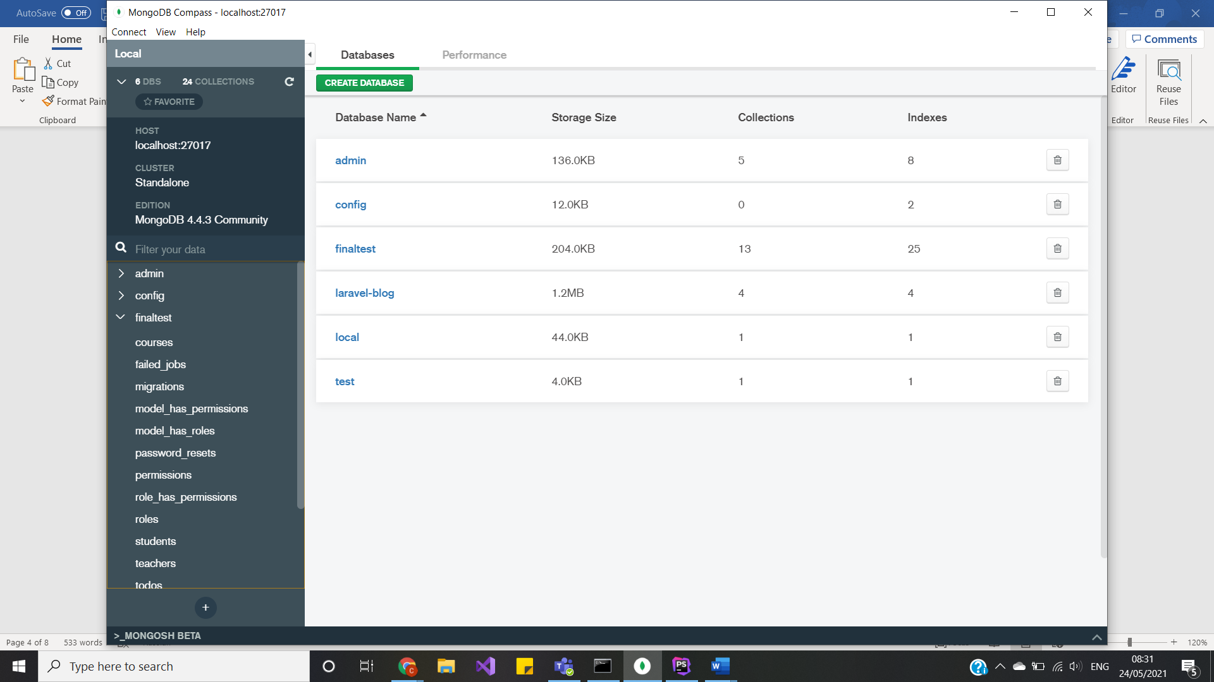

The details of ‘finaltest’ database:

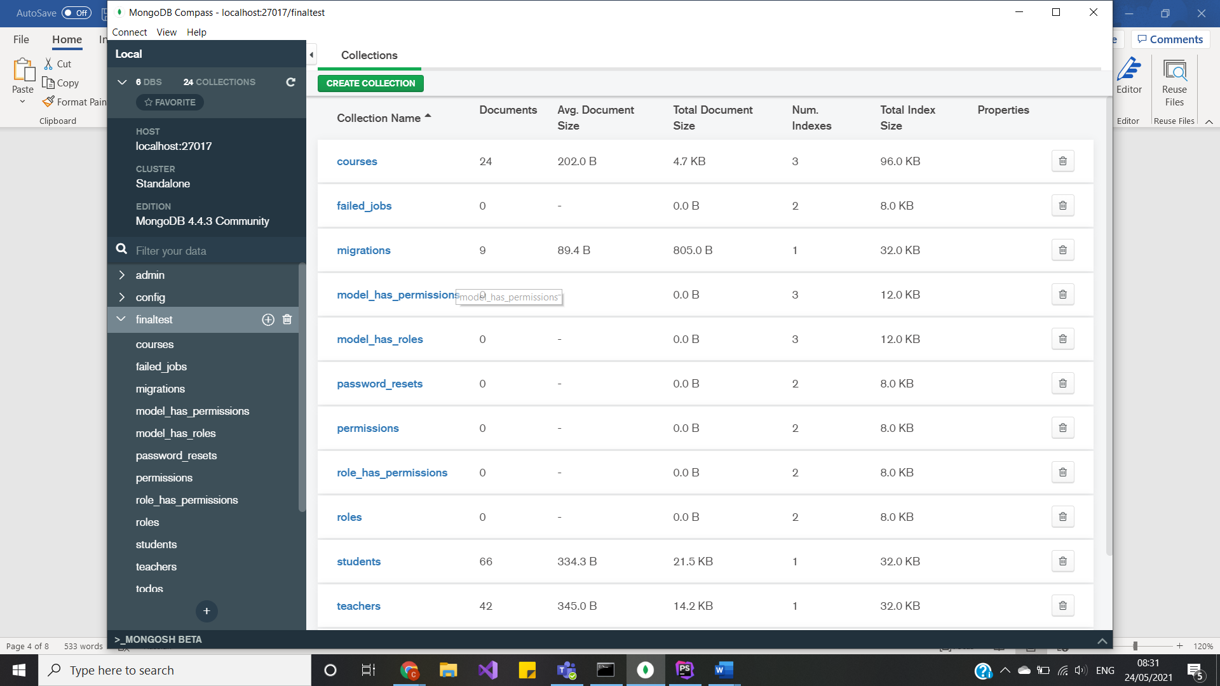

Database connection:

First install, php_monogdb.dll and add the php.ini, then manage Xampp with mongodb feature.

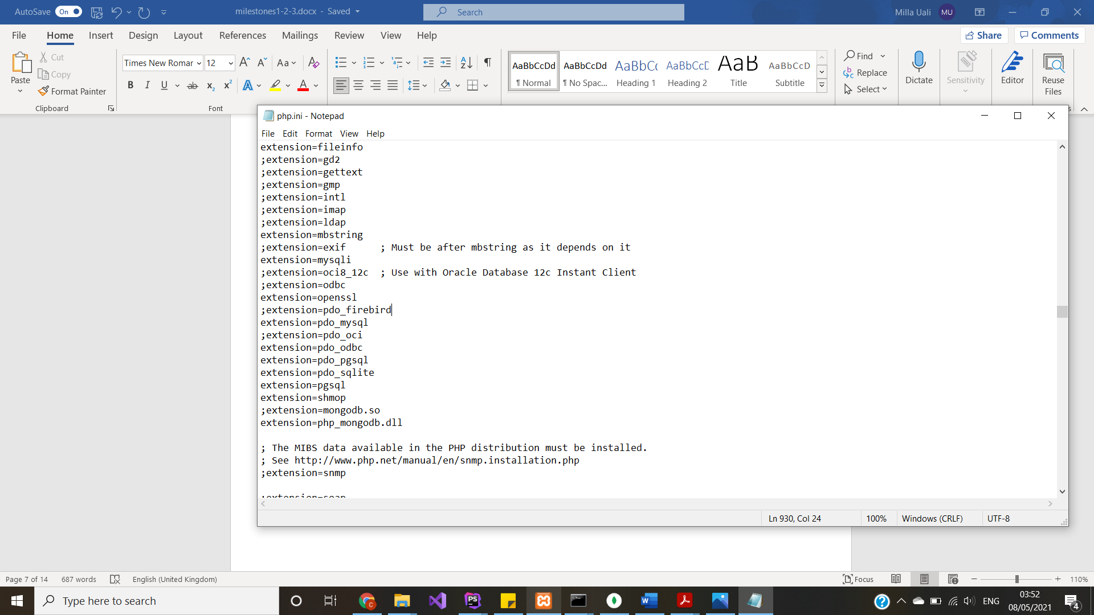

Add extension to xampp.

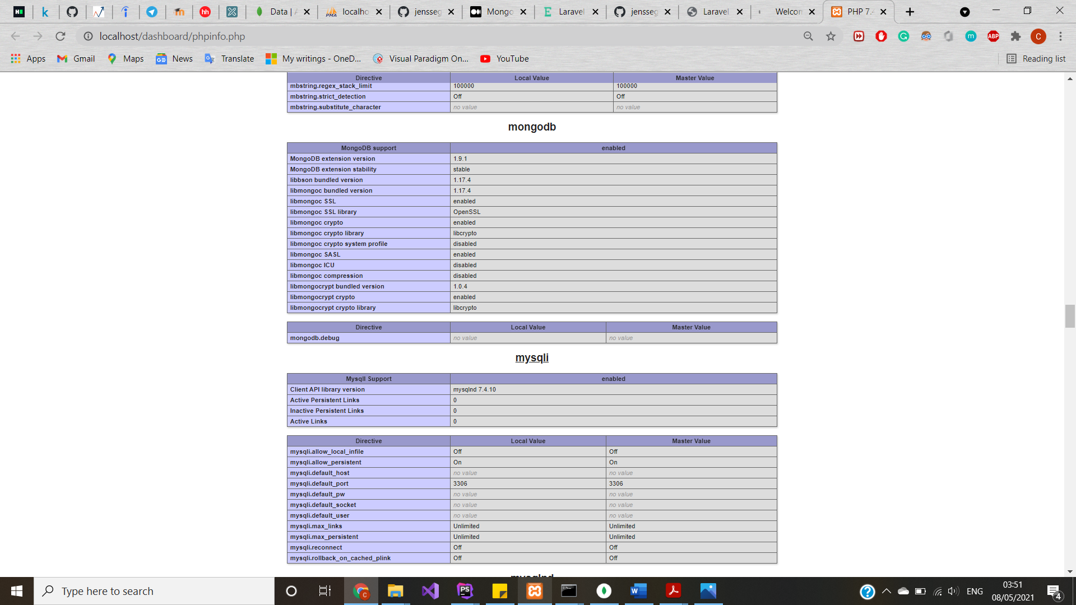

Then, create new Laravel project with MongoDB extension. And add new package, running this code in terminal: composer require jenssegers/mongodb.

After that, modify configuration files: first, app.php file:

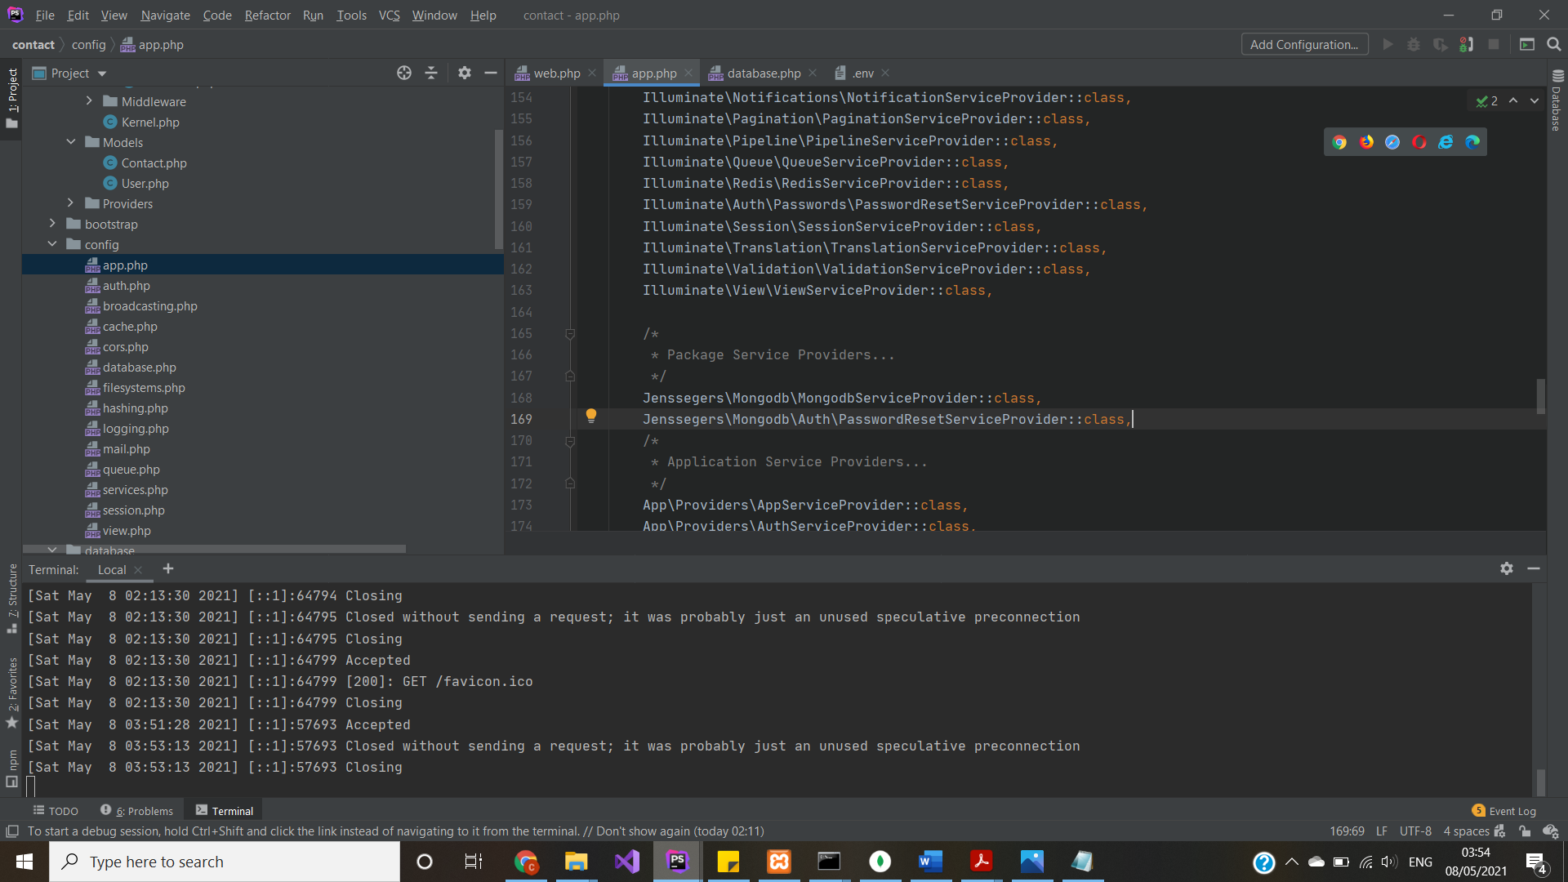

.env file:

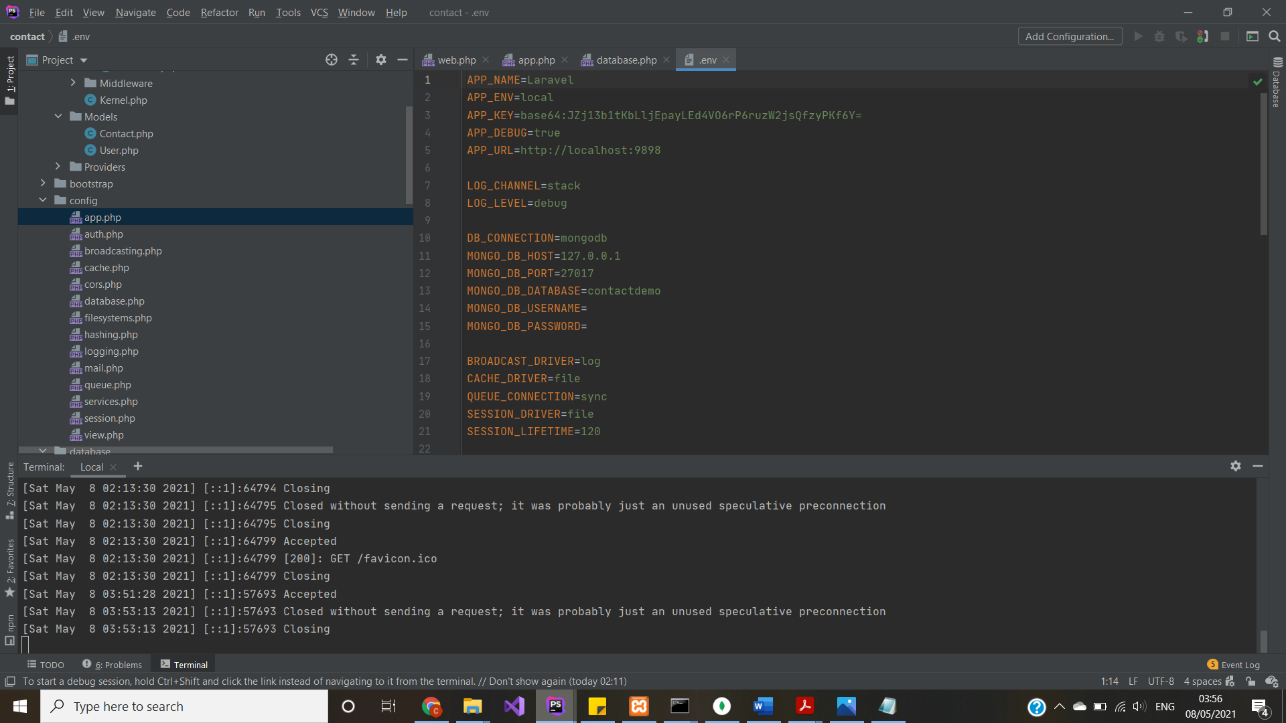

database.php file:

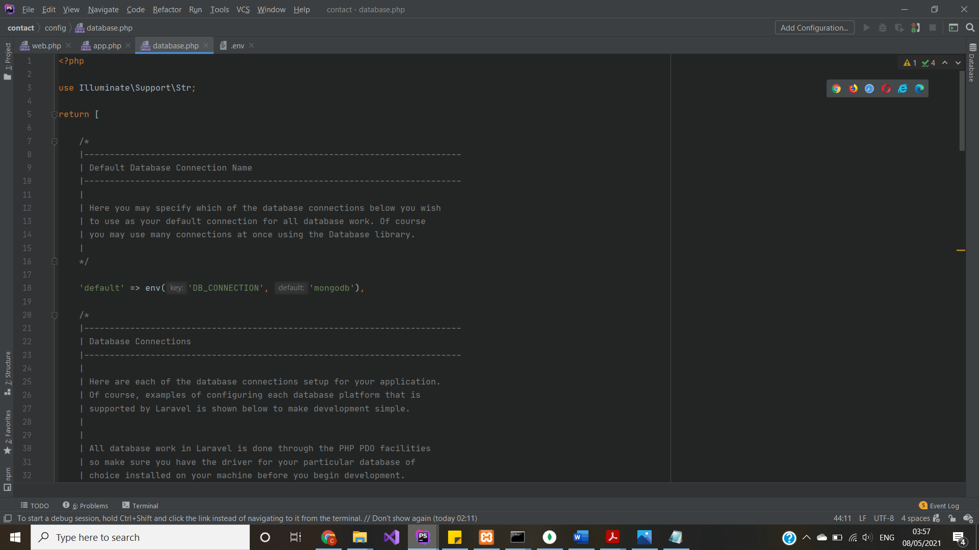

And

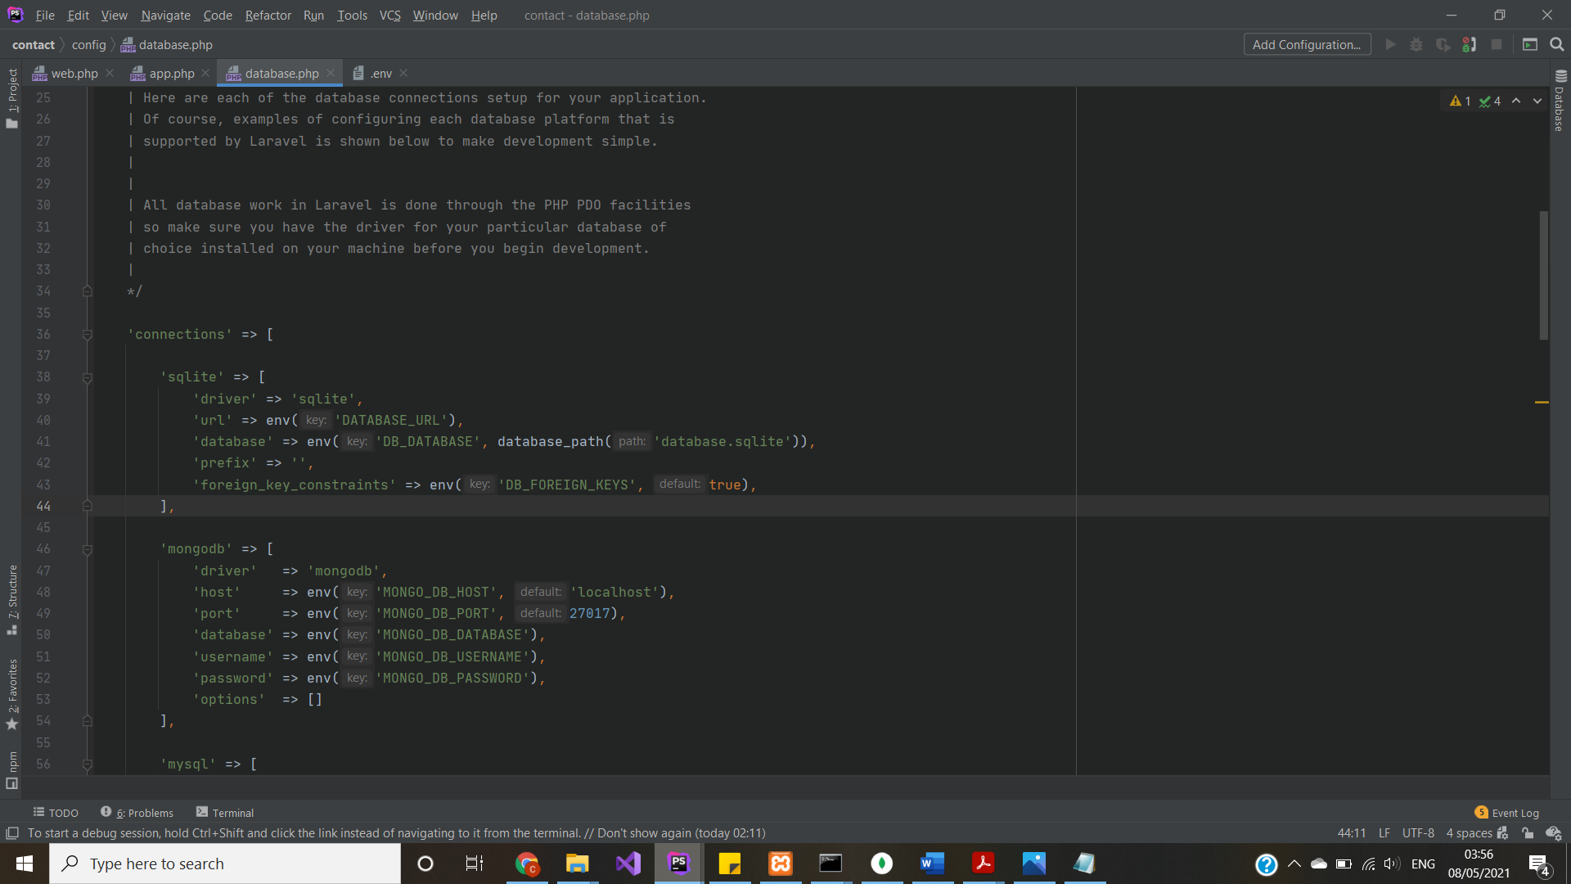

Run mongoshell and mongod, you do not actually have to, unless you want to check righteousness of you queries:

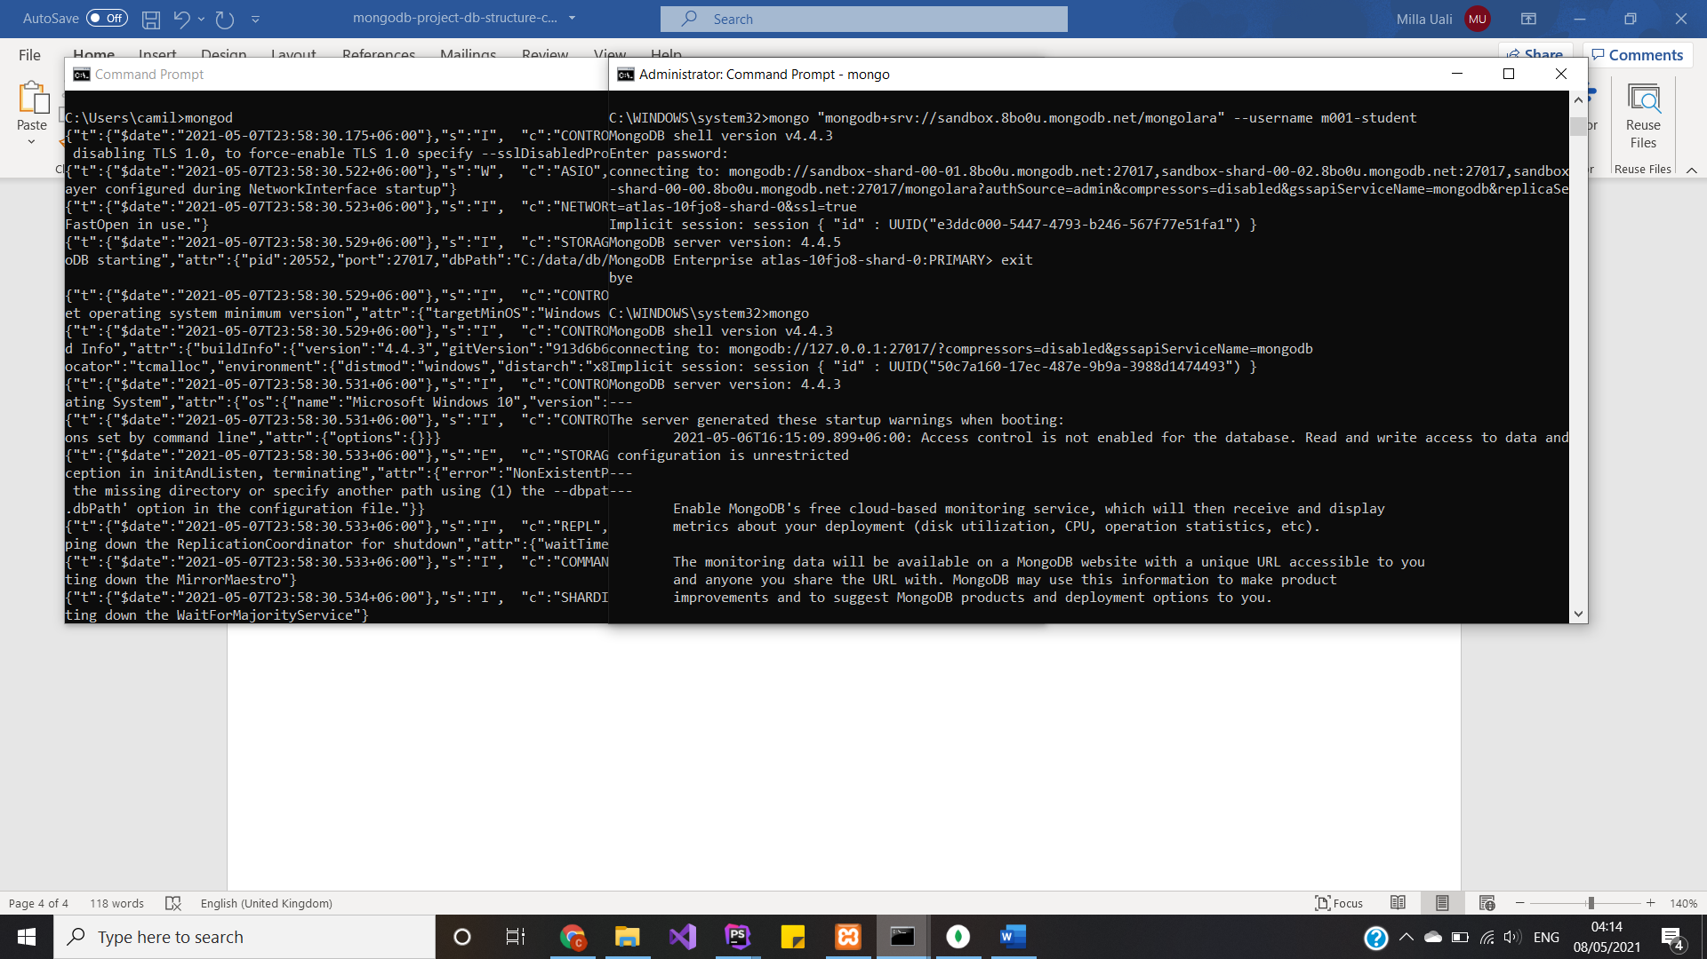

Change in Models:

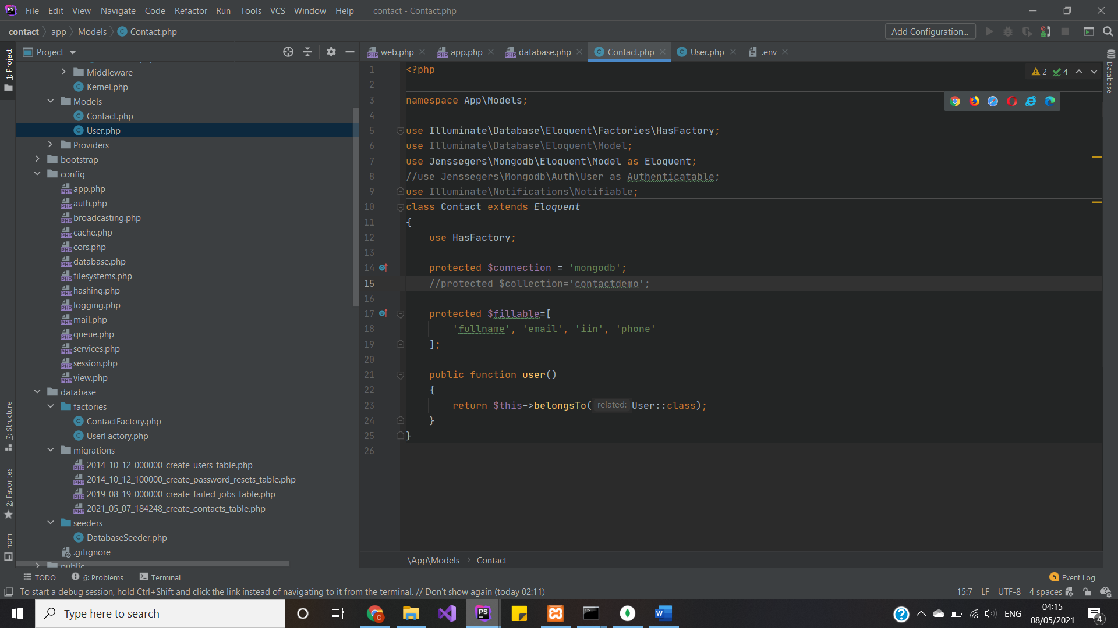

Auth models:

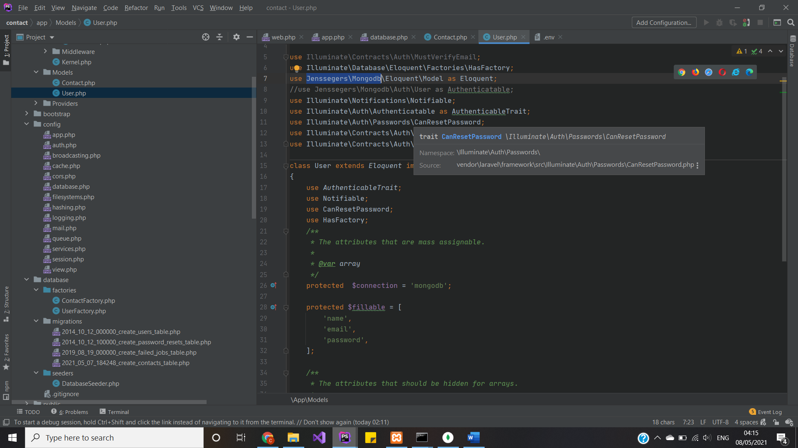

Schema files pretty much the same, yet we can use different approach, by just creating function, yet did not work so I did nothing:

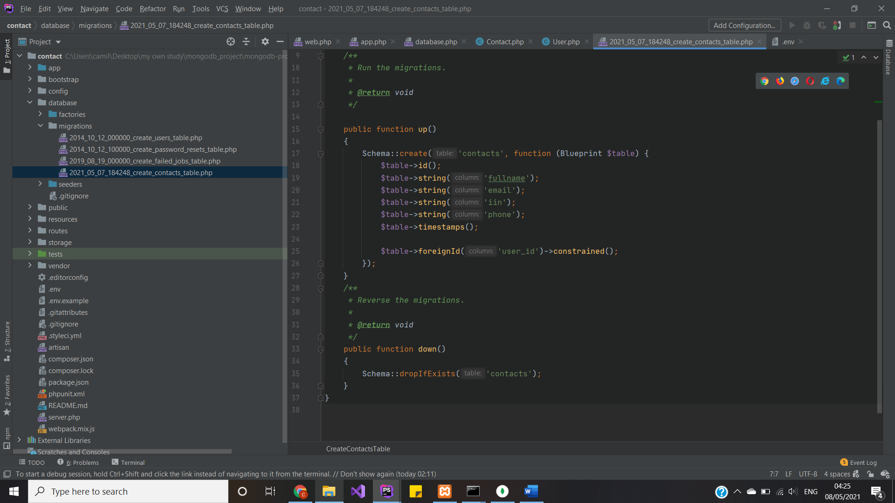

Other files stay the same, by adding new extension and downloading the package you enabled the mongodb database connection. After all changes do not forget to run: *composer update/dump-autoload, php artisan config/optimizer: clear/cache*.

CRUD operations

Well, here lays the same CRUD operations before. For instance, here is the code for Course Model of CRUD operation:

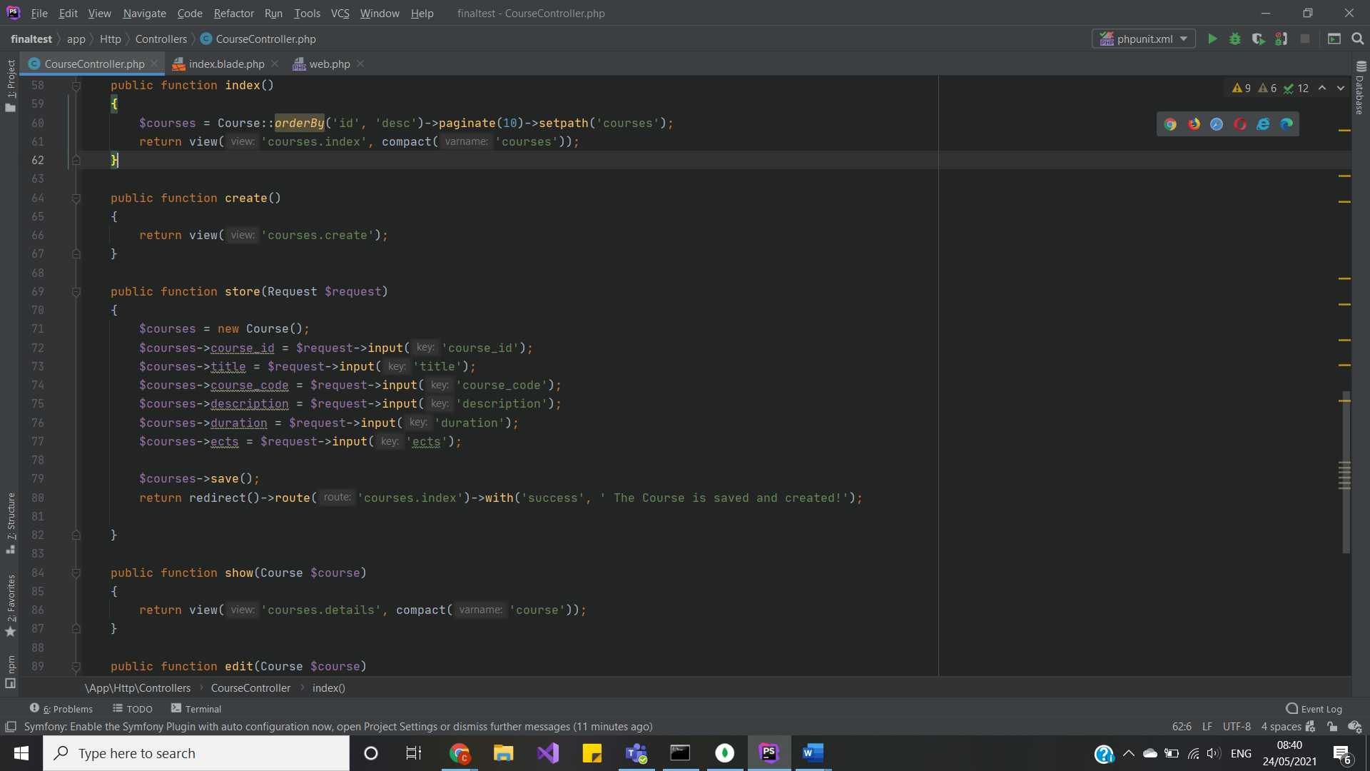

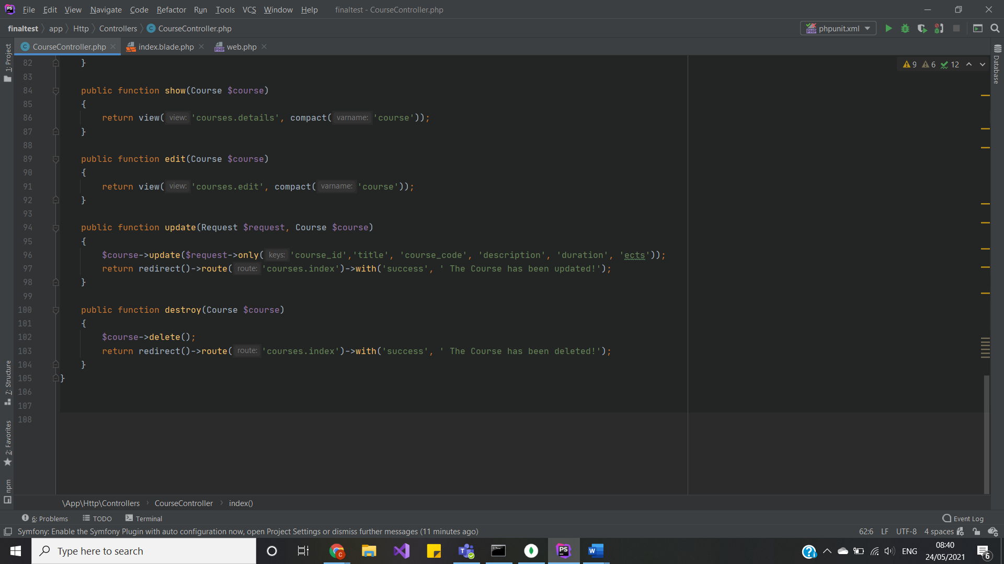

Because we use MVC pattern, the controller handles everything. In model I defined values I will be working with.

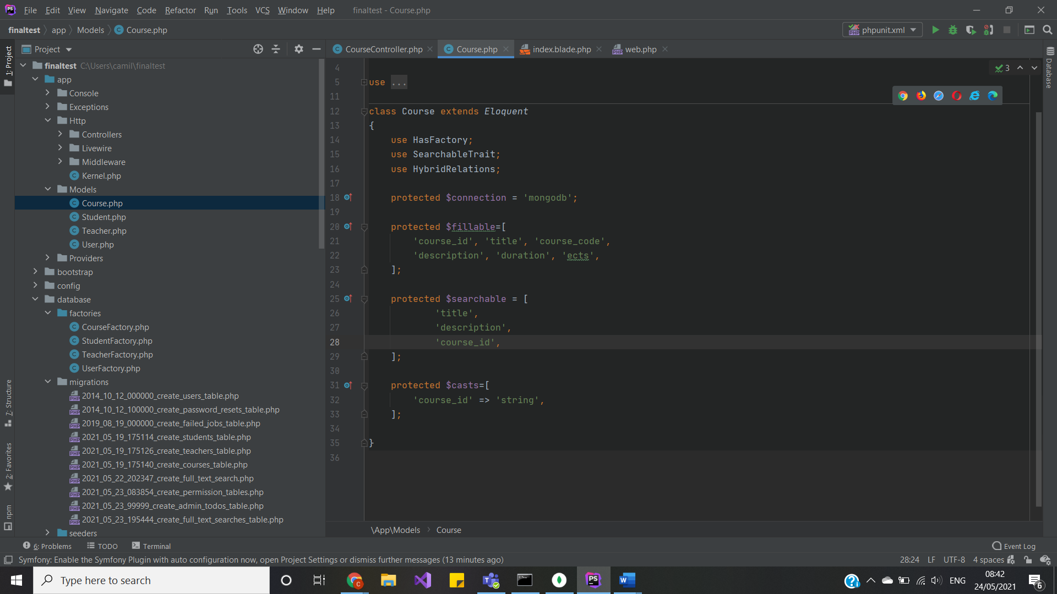

In views, how every function will be displayed. Here the sample, how it looks:

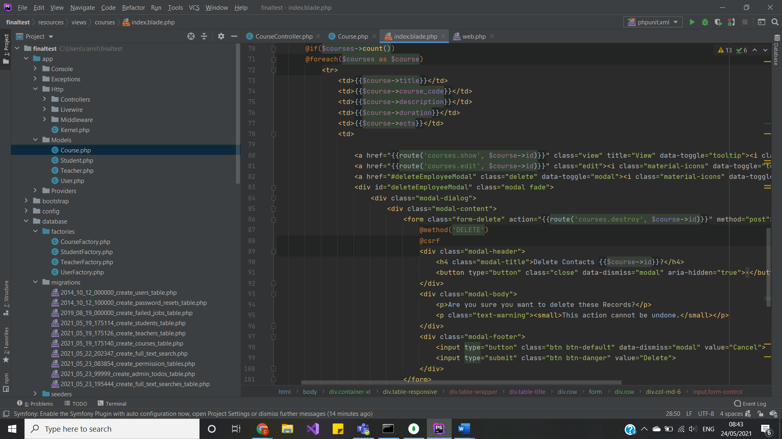

The same agenda works for all Models and controllers inside the project.

Functions and Mongo DB queries

I have written several Mongo DB queries to test and work with, and other functions. So, lest see the query and its results.

* Student controller (collection):

Find all ‘other’ genders and its count - db.students.find({ gender: {$eq: "other"}}).count()

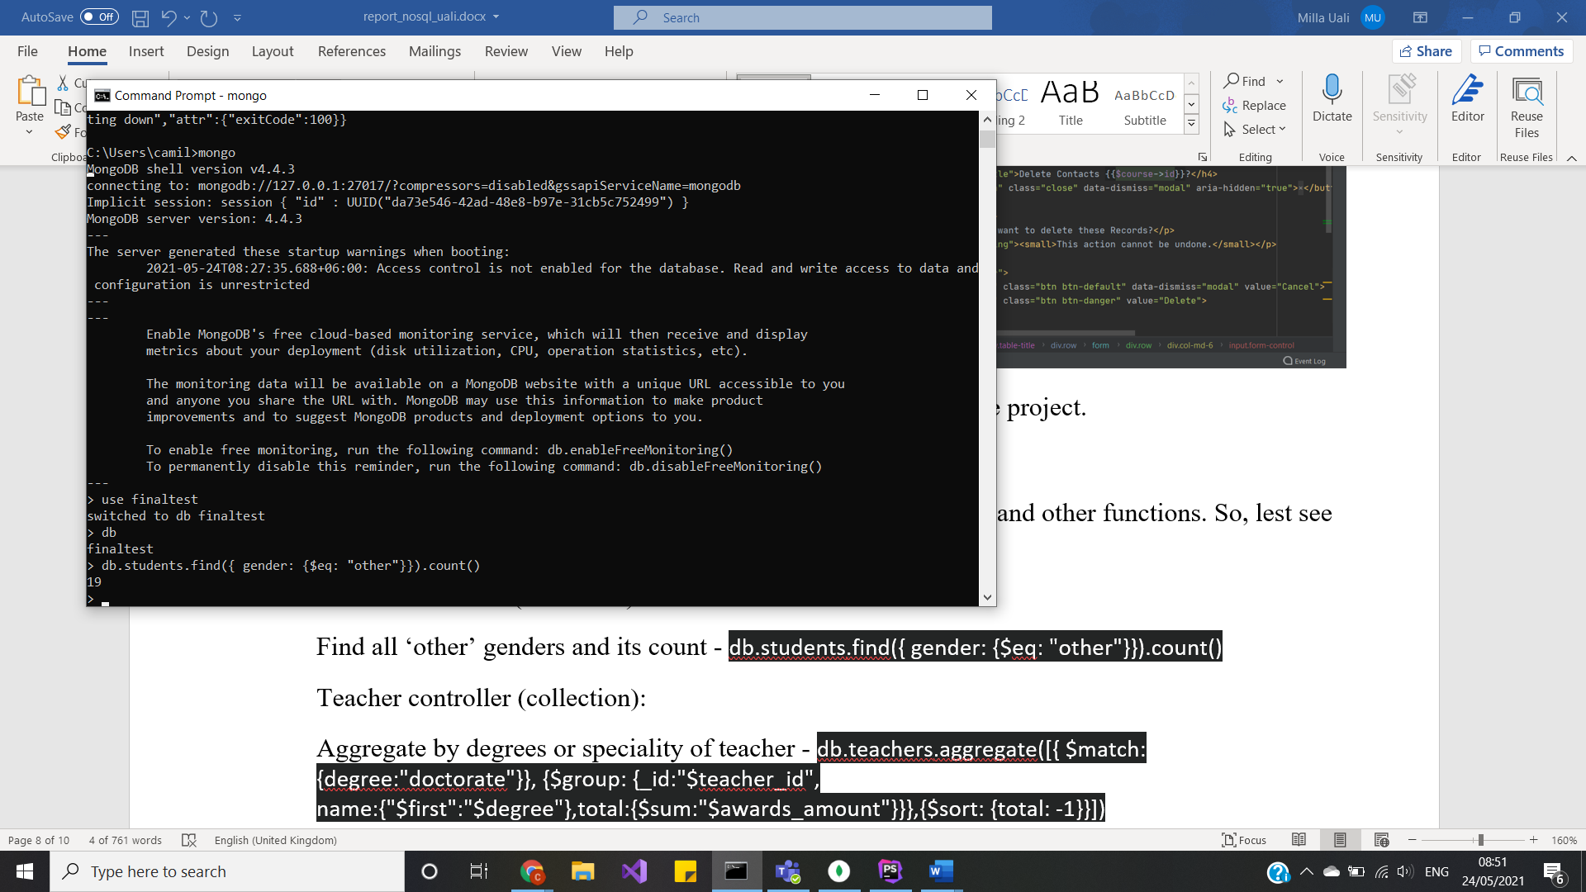

Don’t have to use as administrator, juts run the queries in the shell to see the correctness and possible outcome.

* Teacher controller (collection):

Aggregate by degrees or speciality of teacher - db.teachers.aggregate([{ $match: {degree:"doctorate"}}, {$group: {_id:"$teacher_id", name:{"$first":"$degree"},total:{$sum:"$awards_amount"}}},{$sort: {total: -1}}])

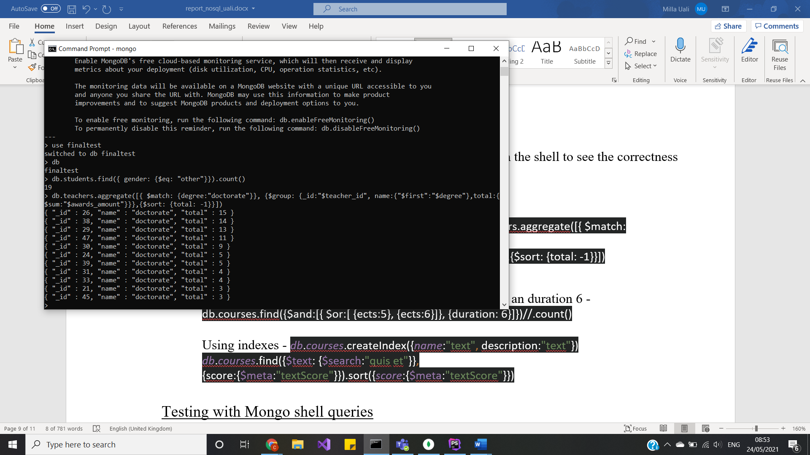

* Course controller (collection):

$find, $or, $and functions to find count of ECTS equal 5 an duration 6 - db.courses.find({$and:[{ $or:[ {ects:5}, {ects:6}]}, {duration: 6}]})//.count()

*Changed the parameter and got results:*

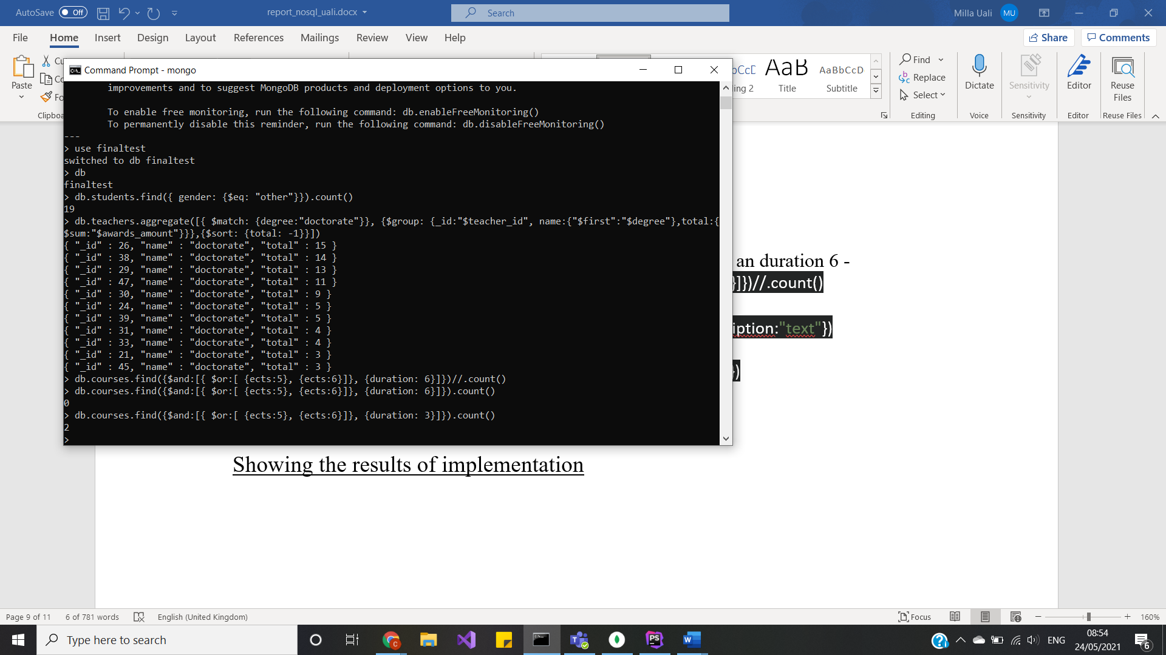

Using indexes - *db*.*courses*.createIndex({*name*:"text", description:"text"})  
*db*.*courses*.find({$text: {$search:"quis et"}}, {score:{$meta:"textScore"}}).sort({*score*:{$meta:"textScore"}})

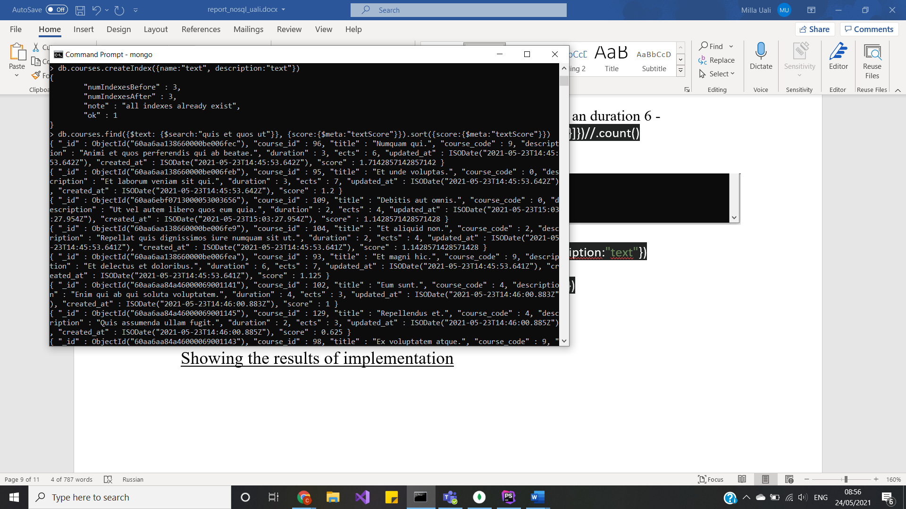

And now let’s see the result values:

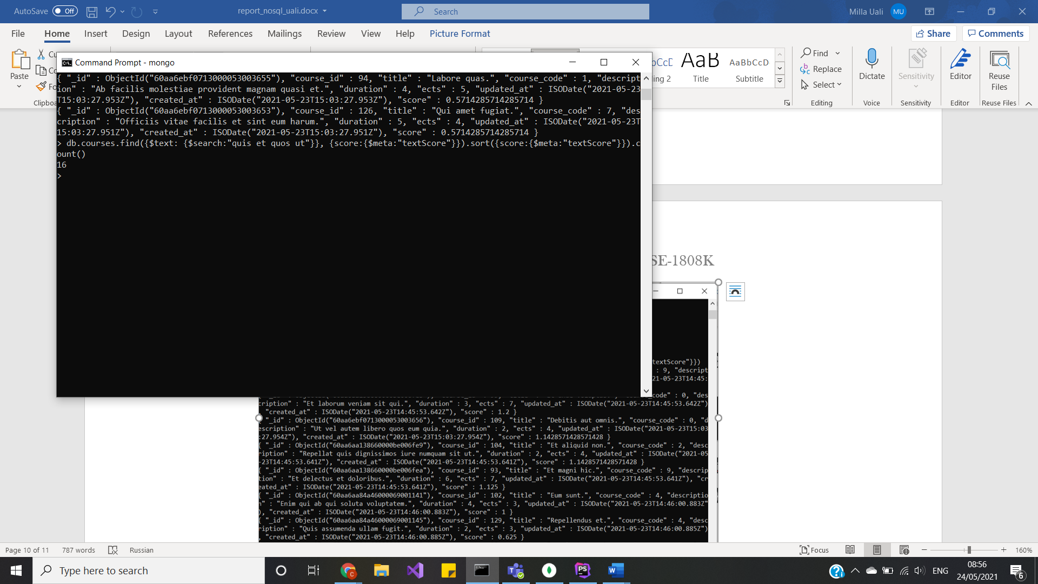

Testing with Mongo shell queries

I don’t have to implement exact the same queries, the ones above are just tests so I would understand how I am going to filter my data. As well, I chose to use the exact the same queries above for my filter parameters.

* Filter by Data:

I looked through manual and understood filter by condition or passing variables using find query. I wrote this filter:

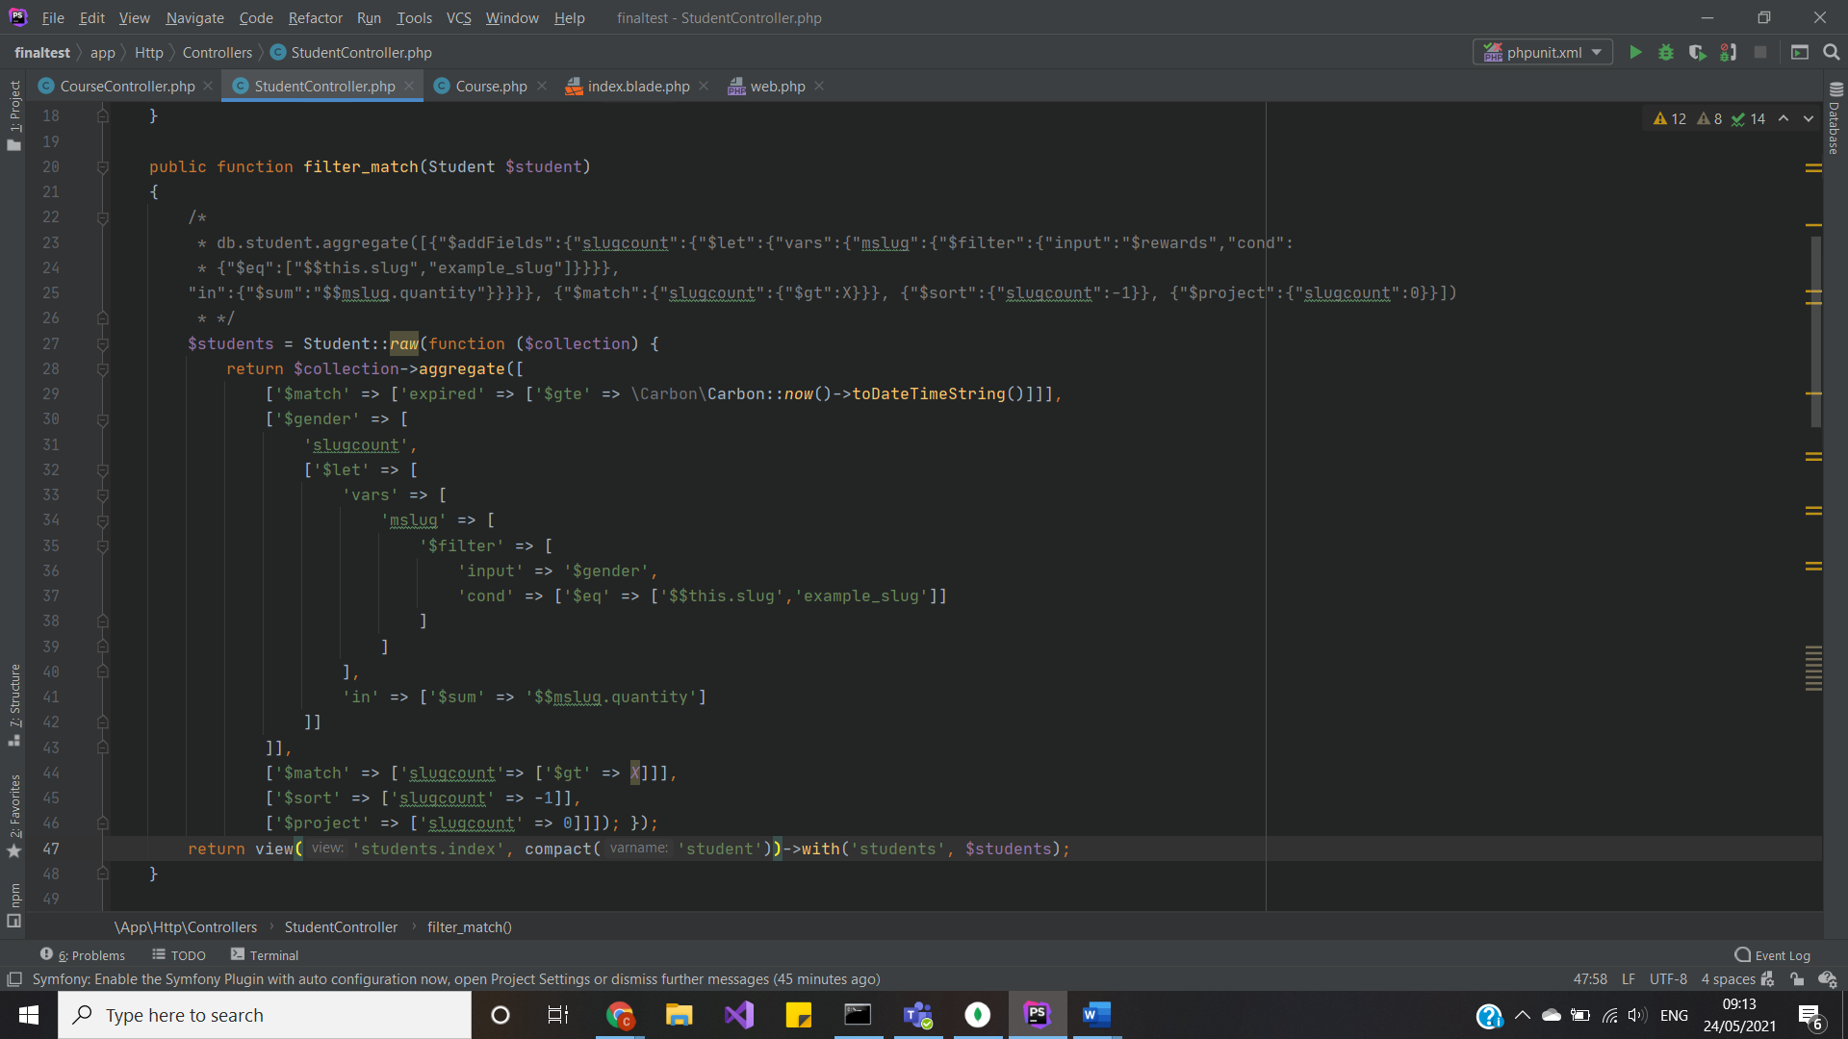

Yet, it is too complicated, and I can simplify it, by converting to Laravel friendly query using jenssegers package:

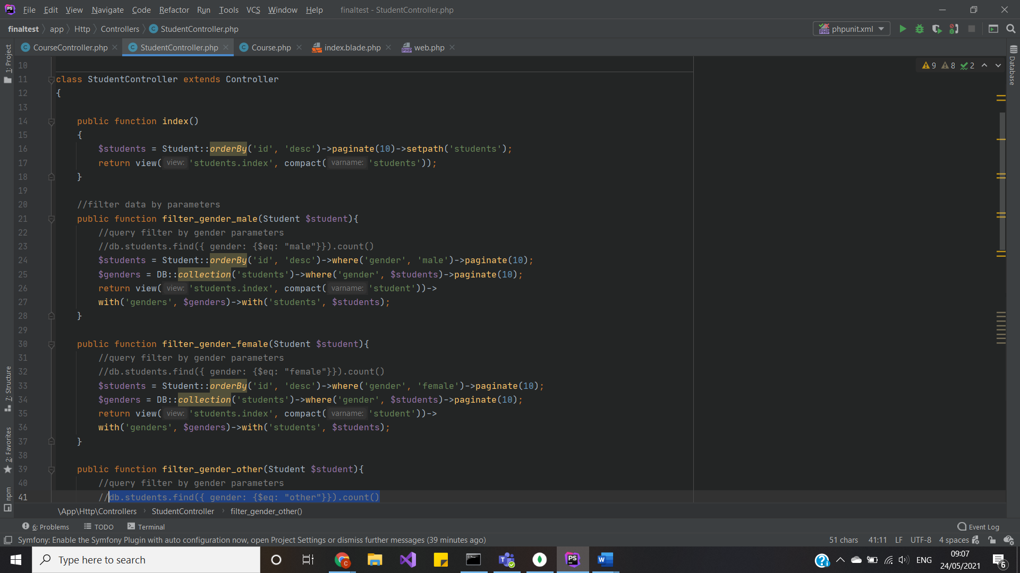

* Aggregation methods:

We can use whereRaw() query or:

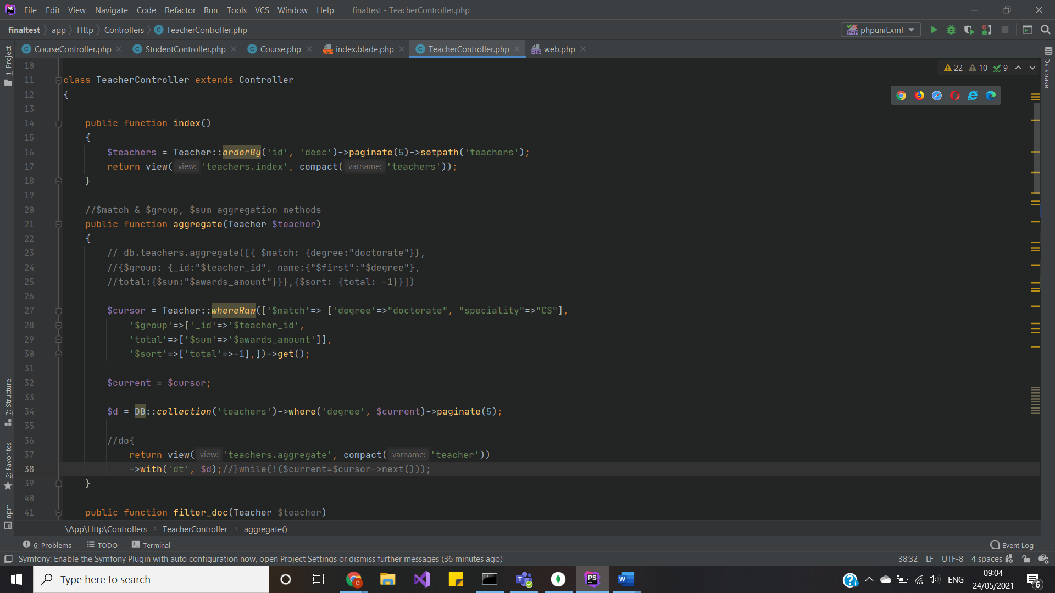

Simply convert Mongo DB query to Laravel:

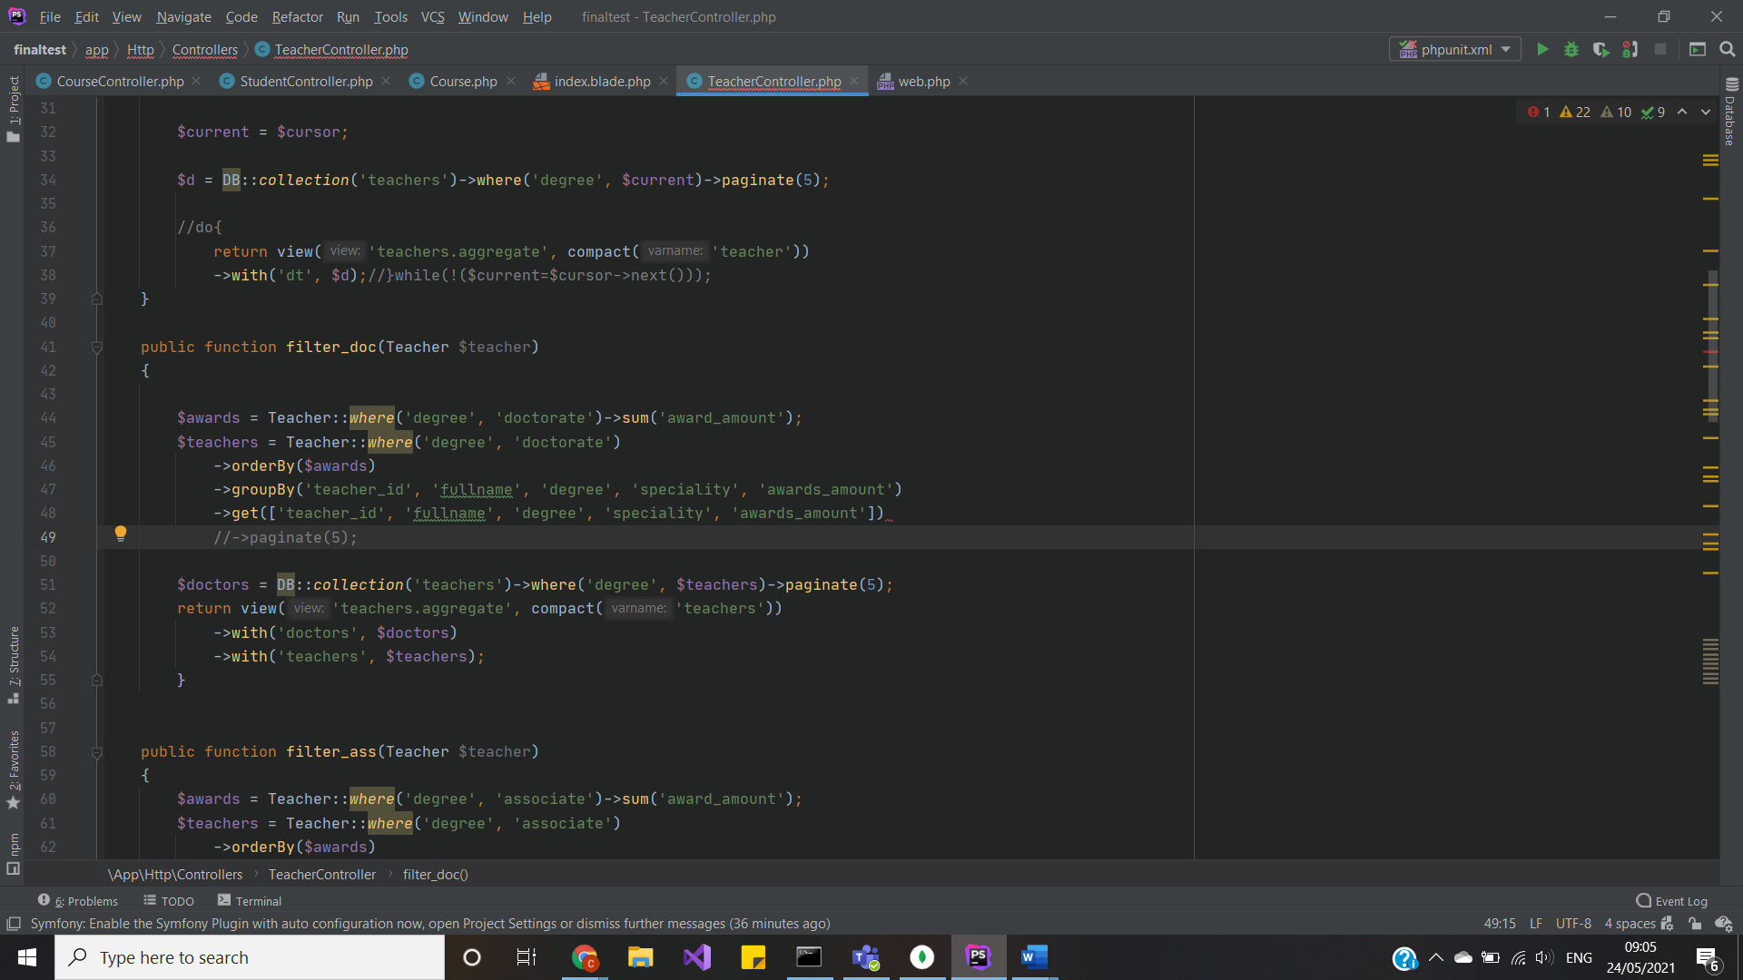

* Using indexes:

Indesing is a bit harder to implement to Laravel framework. First, I created index in Schema(also dropepd it in down() function):

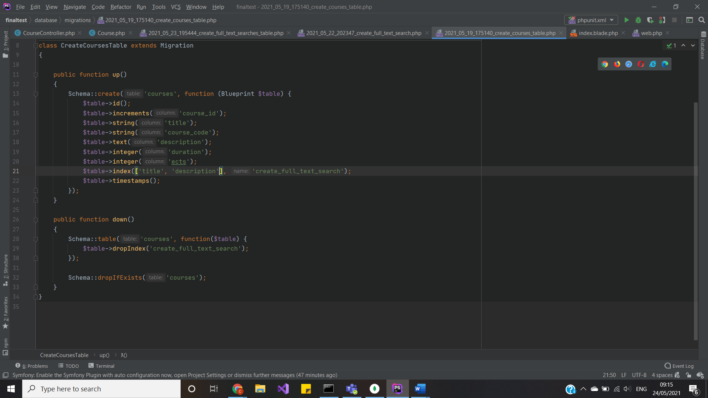

Then have to make the indexes searchable in model:

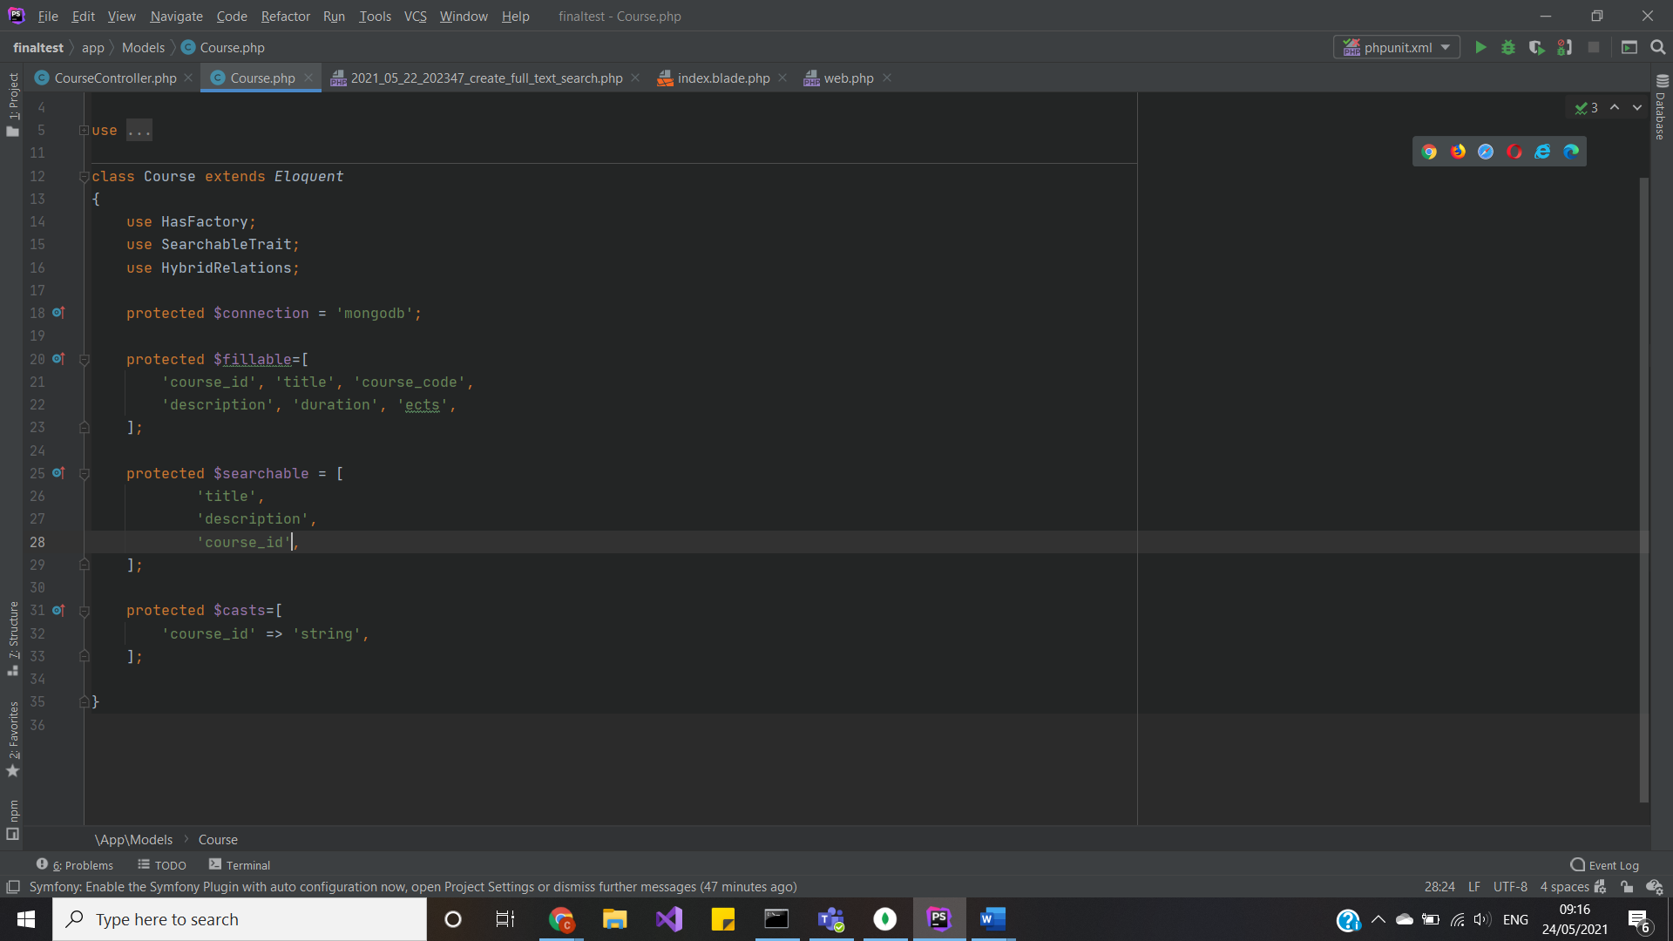

Only after that, created migration that will handle index search:

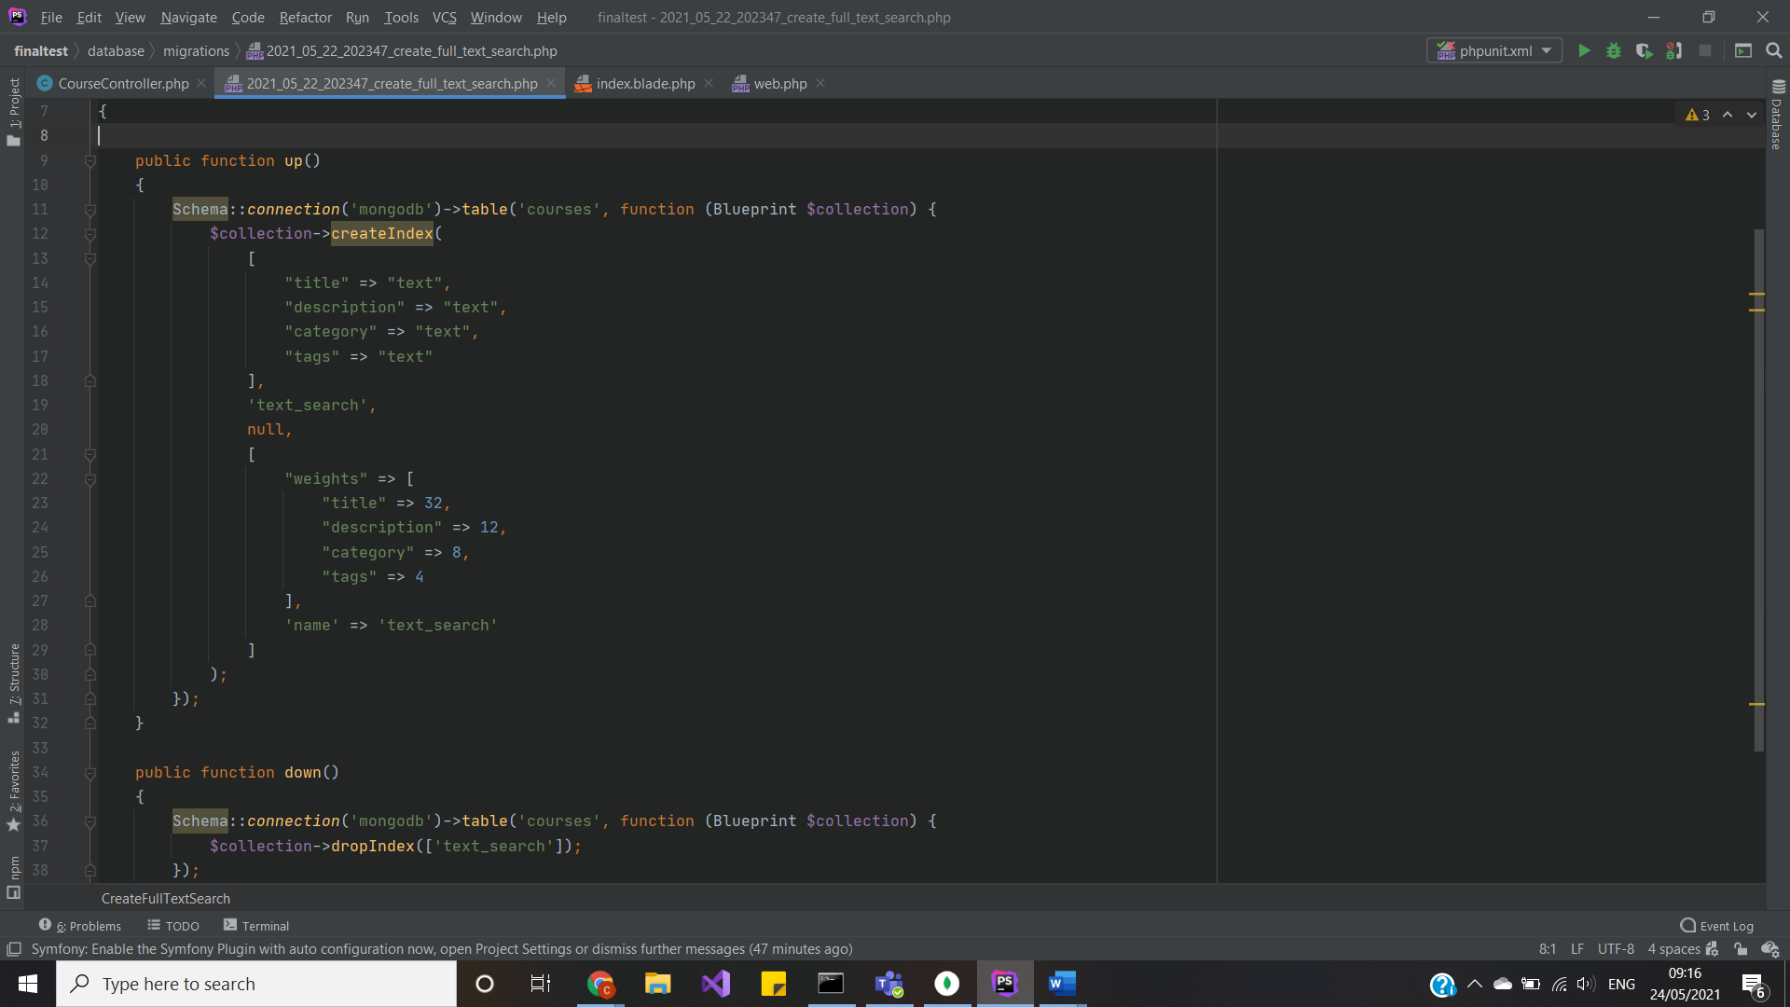

Then in controller, just indexes by simple Laravel queries:

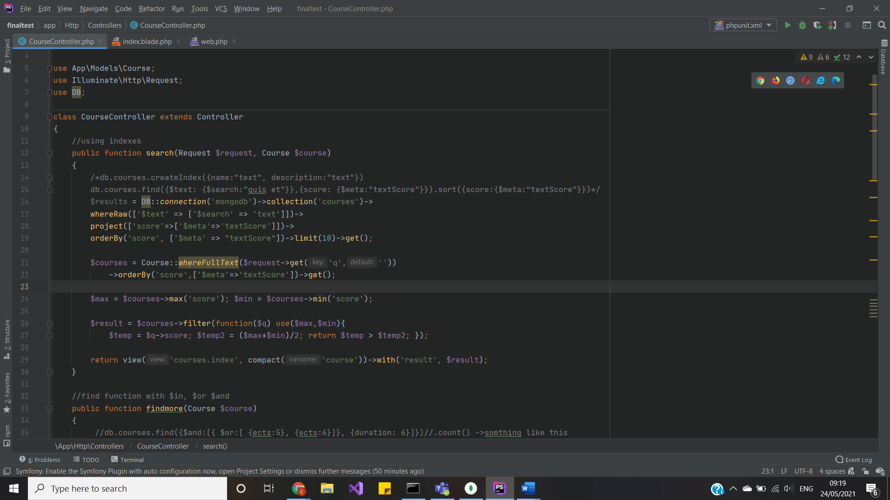

So, here is nice and easy ways to convert Mongo DB queries to Laravel friendly ones.

* Other functions:

Also, I used $in, $and, $find functions, just for filtering data.

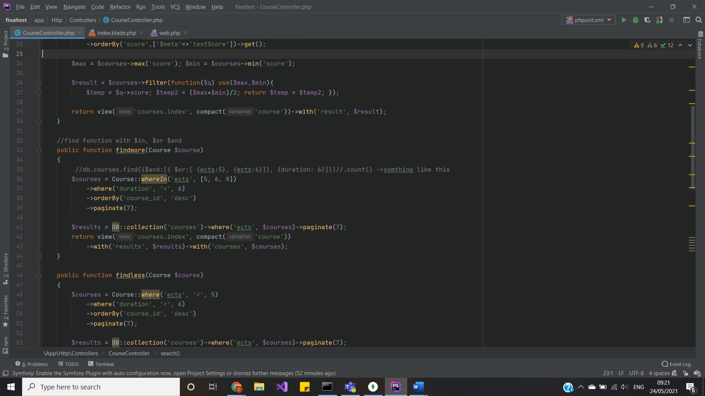

Showing the results of implementation

So, above I explained pretty much everything in this project: database connection, CRUD operations, implementation of Mongo DB queries and converting them to Laravel friendly and showed some code examples. But now, let’s see the outcomes of said code.

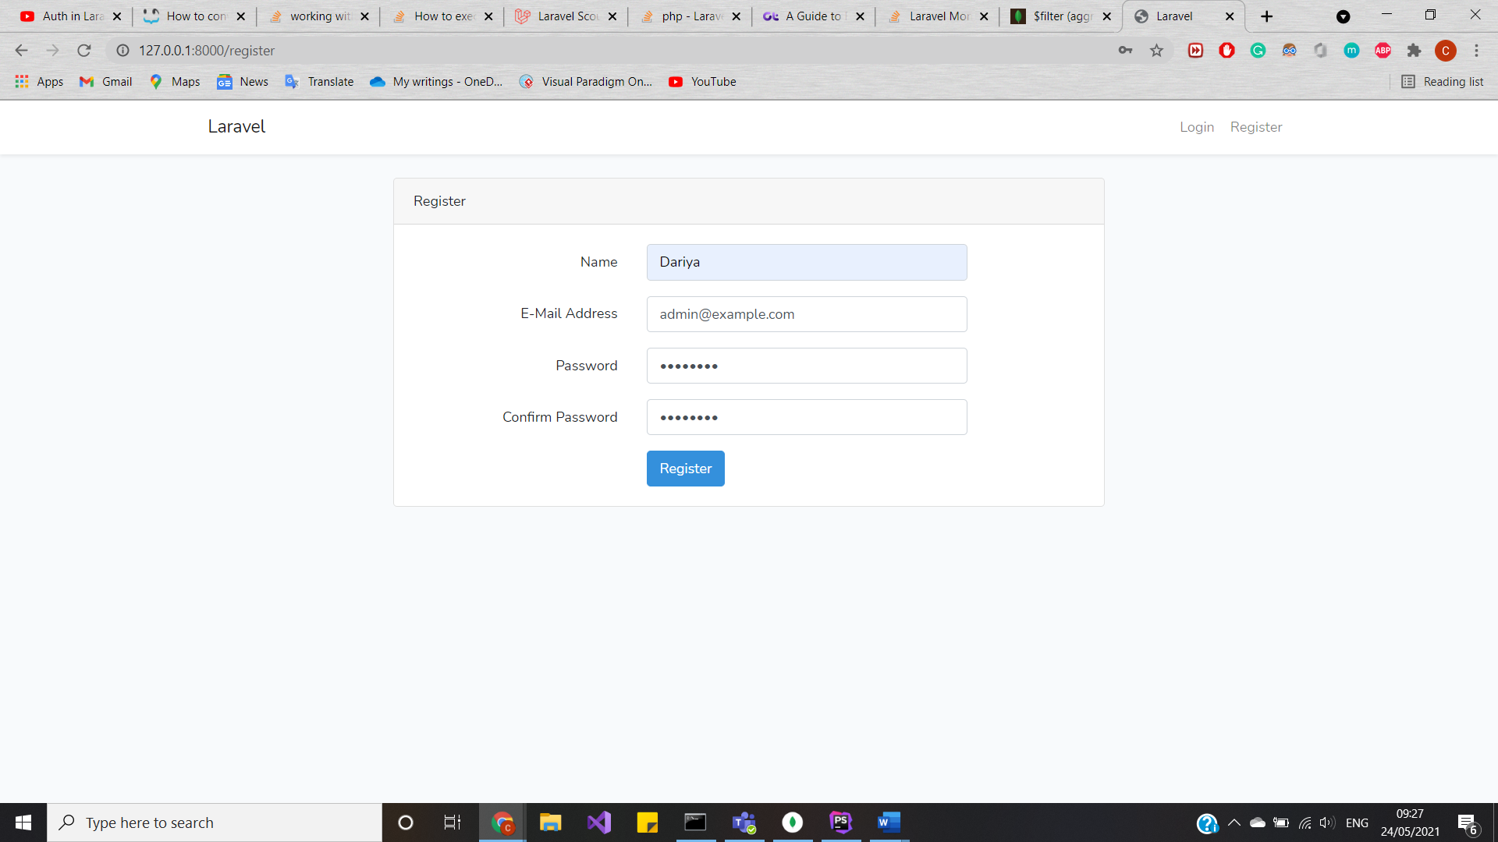

Now, lets go to Students contacts:

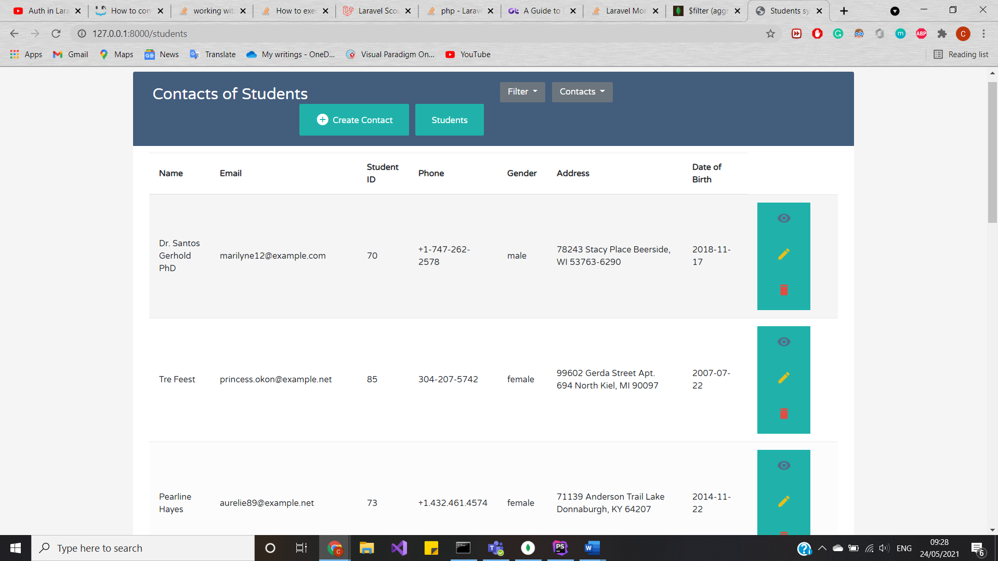

And filter data, where everyone is male:

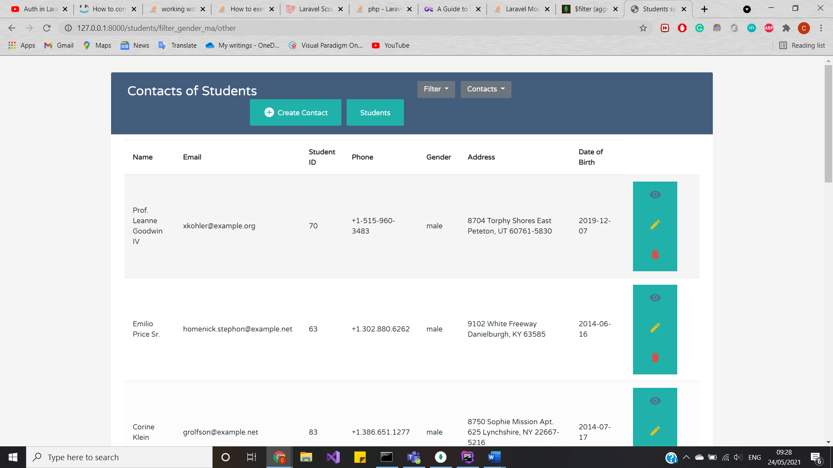

Then check females:

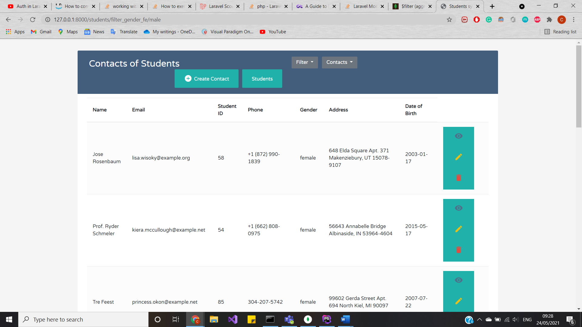

And other genders:

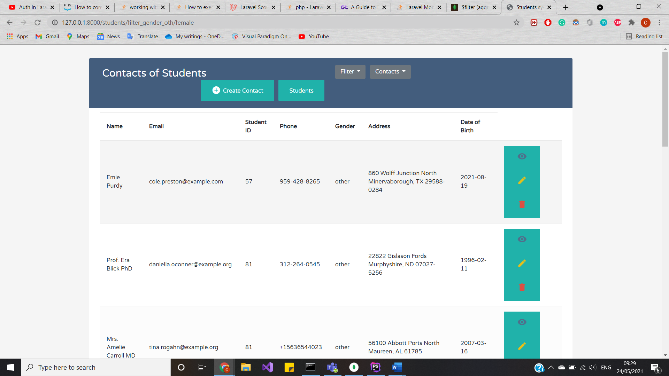

And let’s check the Teachers’ contacts:

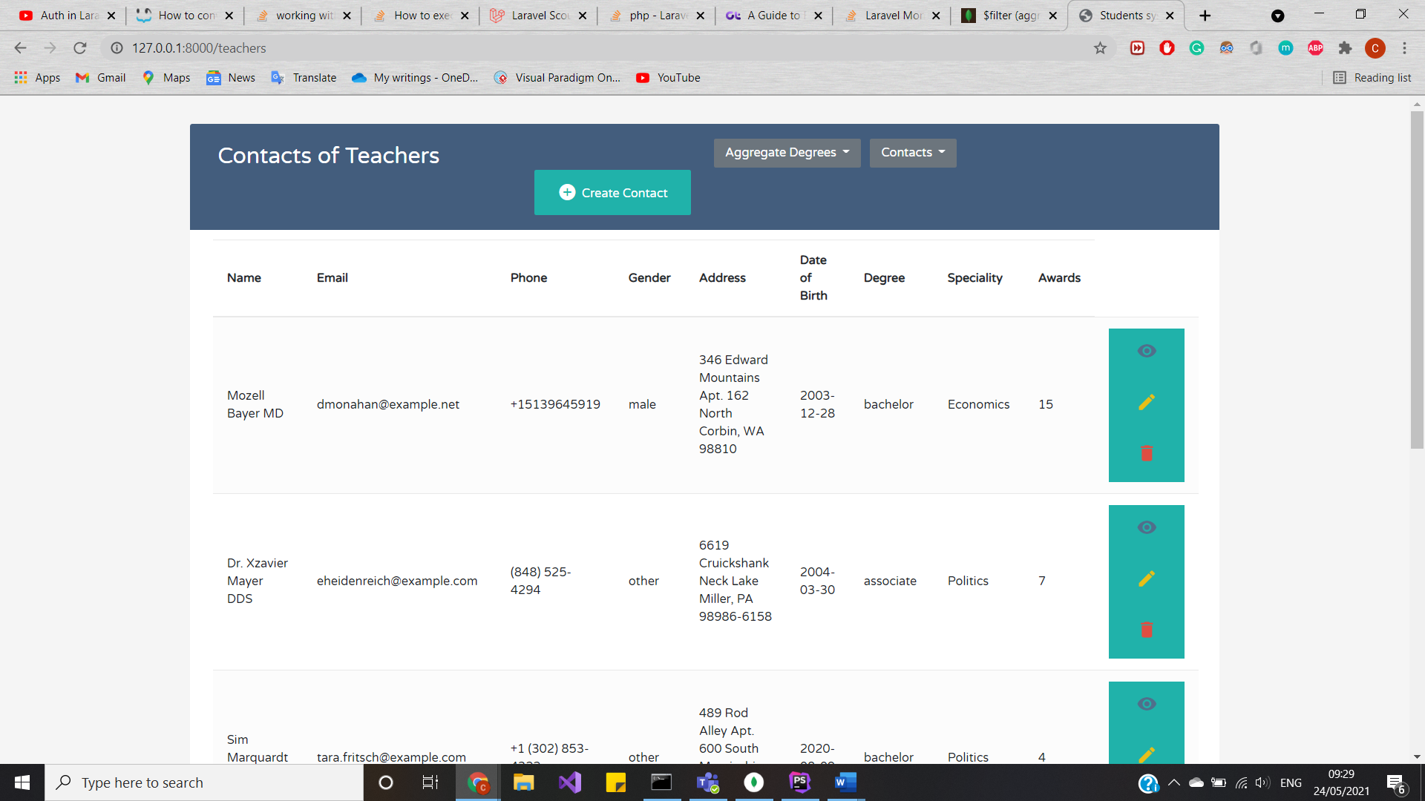

And find only doctors:

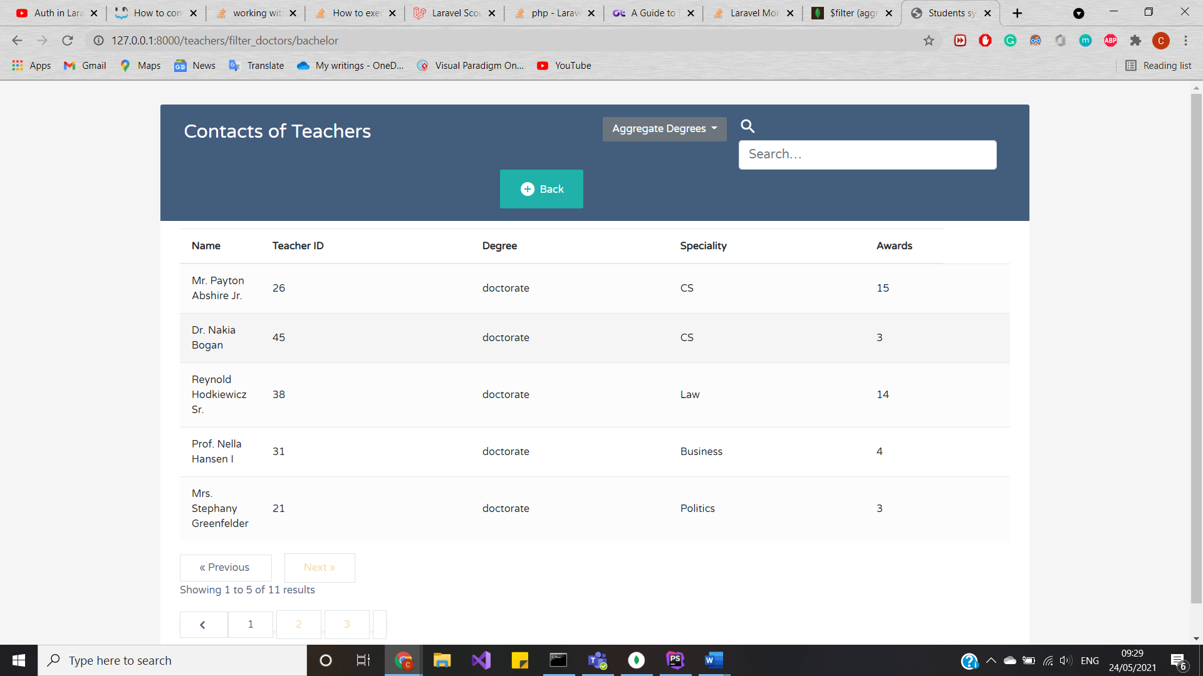

And only masters:

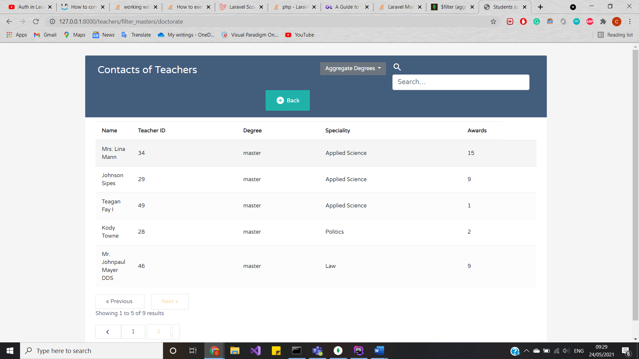

And bachelors:

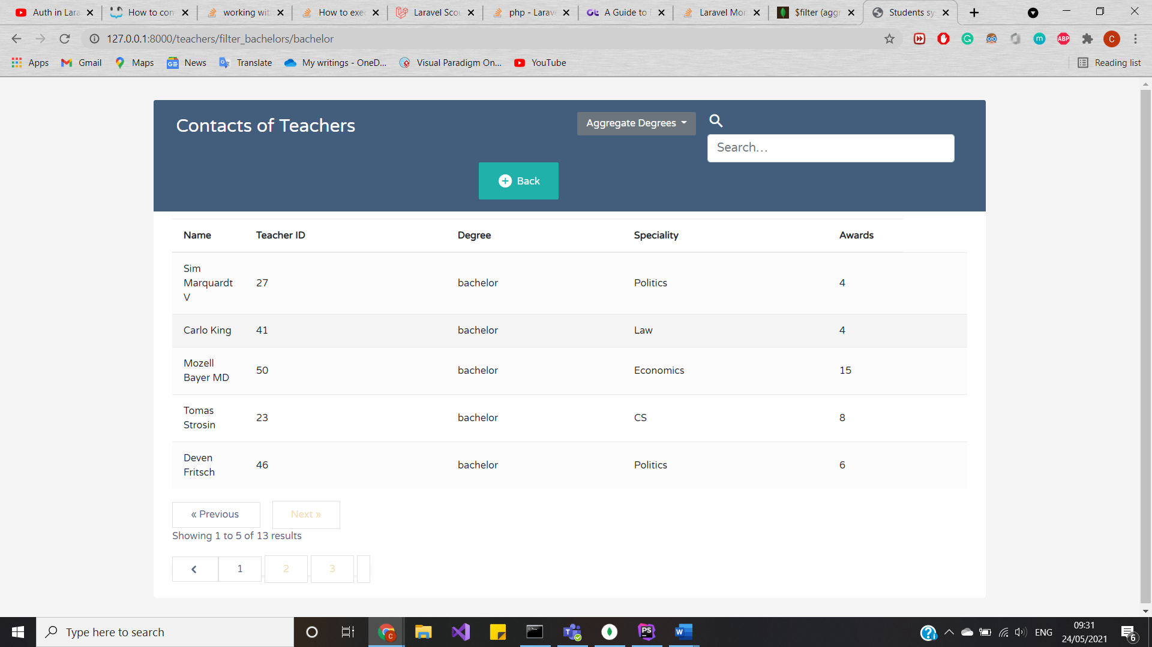

And associates:

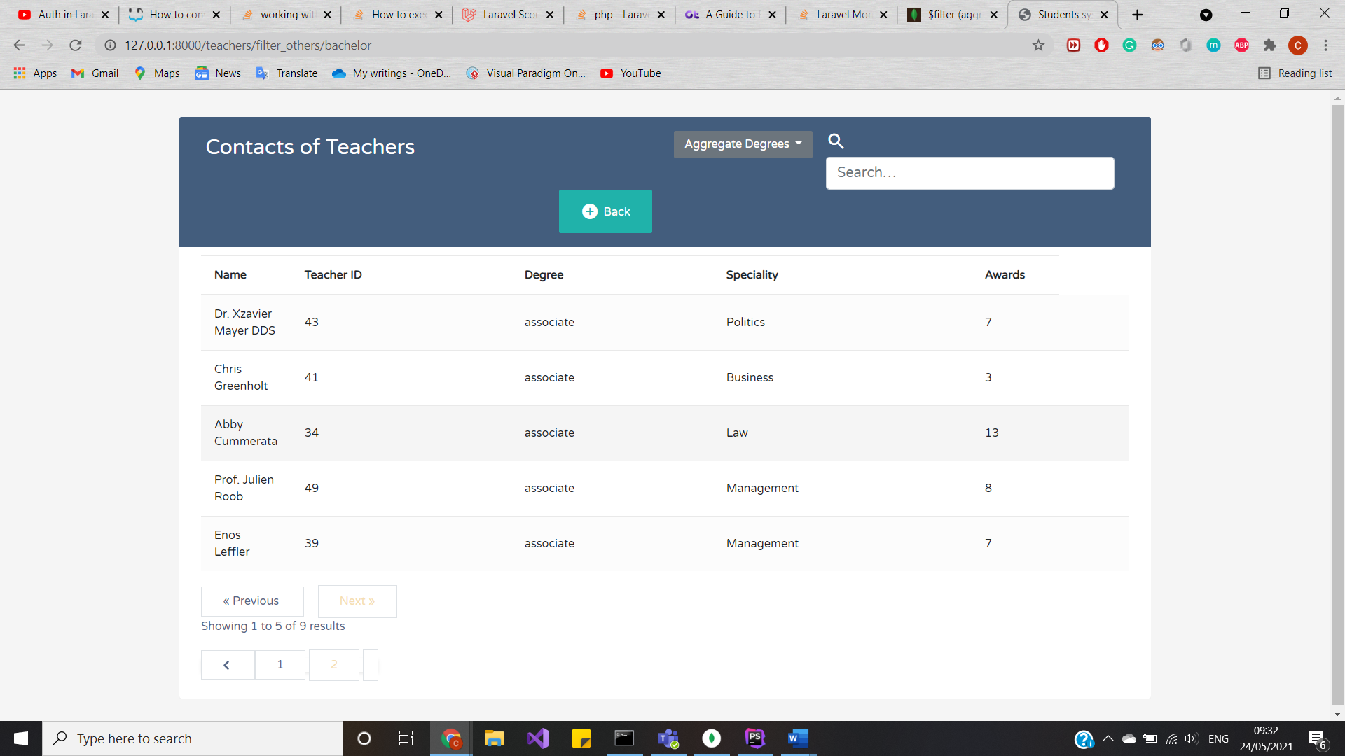

And check out course tables:

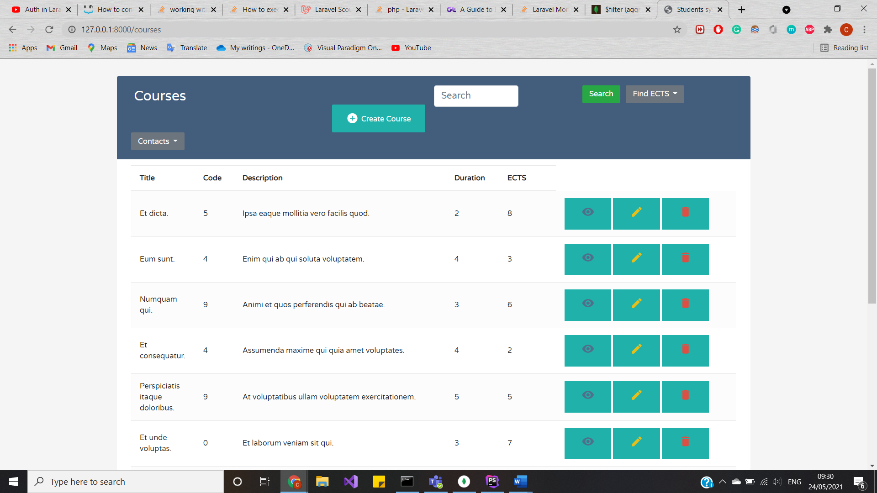

Find the course which ECTS are more than 5:

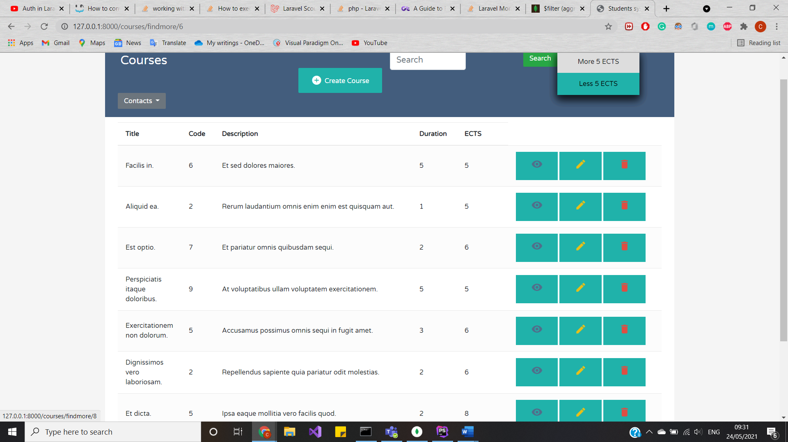

Or when ECTS less than 5, also duration less than 6 months:

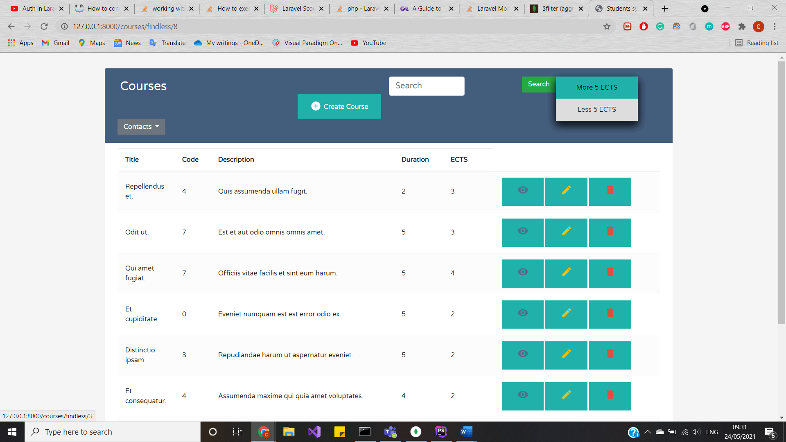

So, here is the end of implementation of each aggregation methods, filter and other functions with CRUD operation and Mongo DB driver.

Some examples of CRUD:

Create:

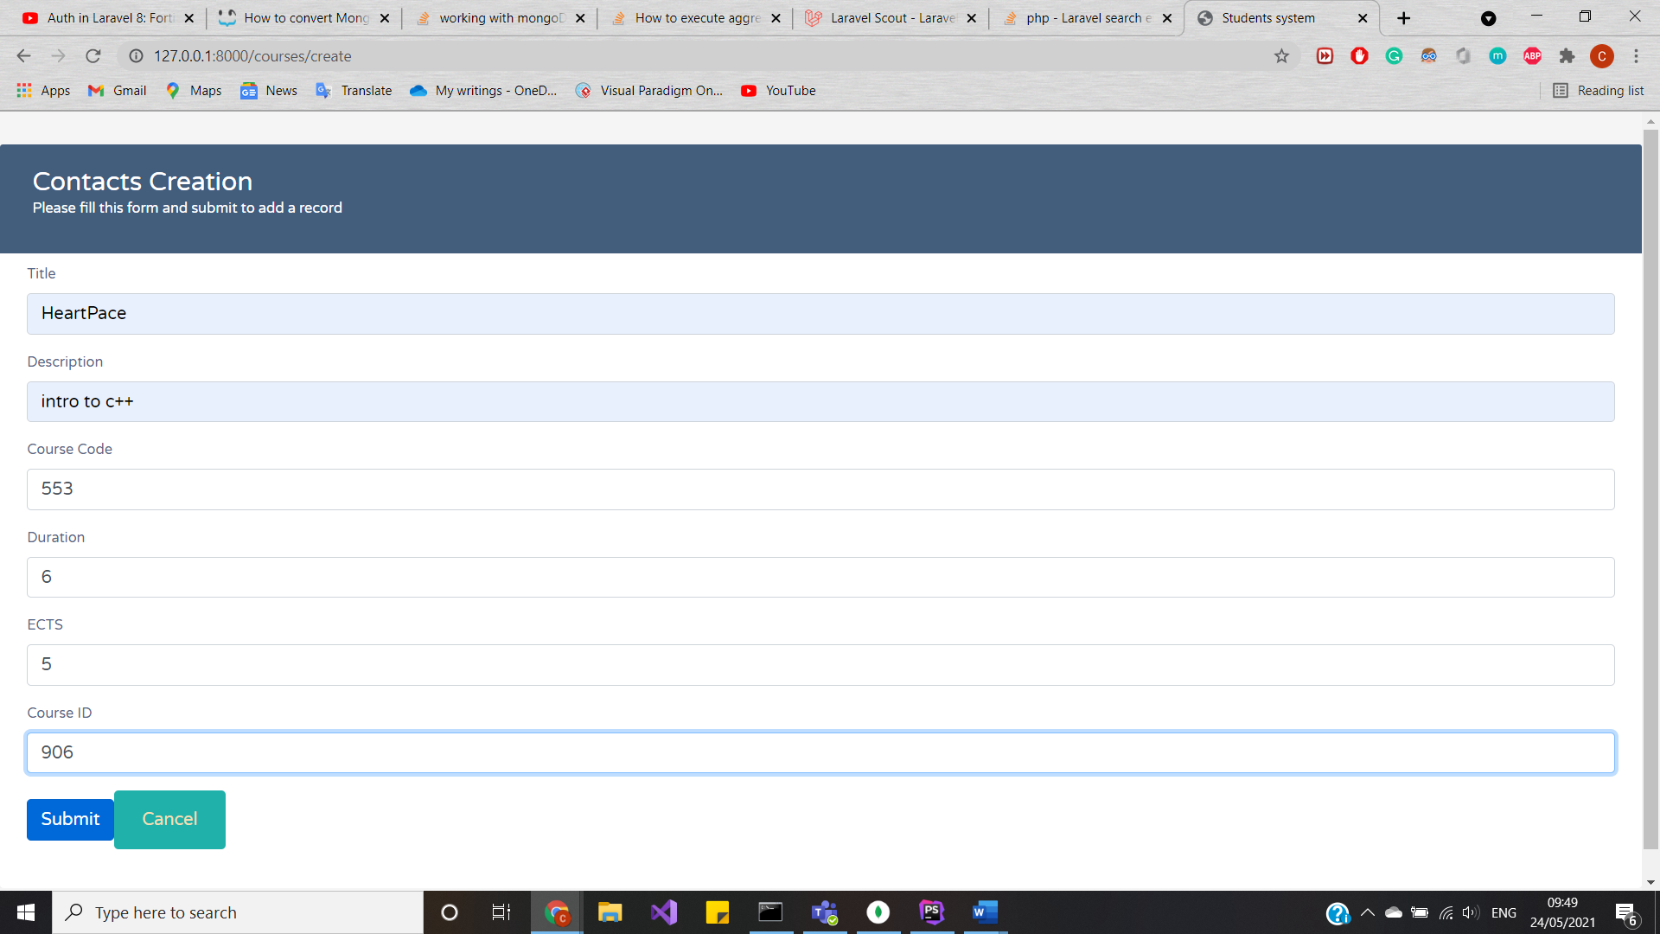

Result:

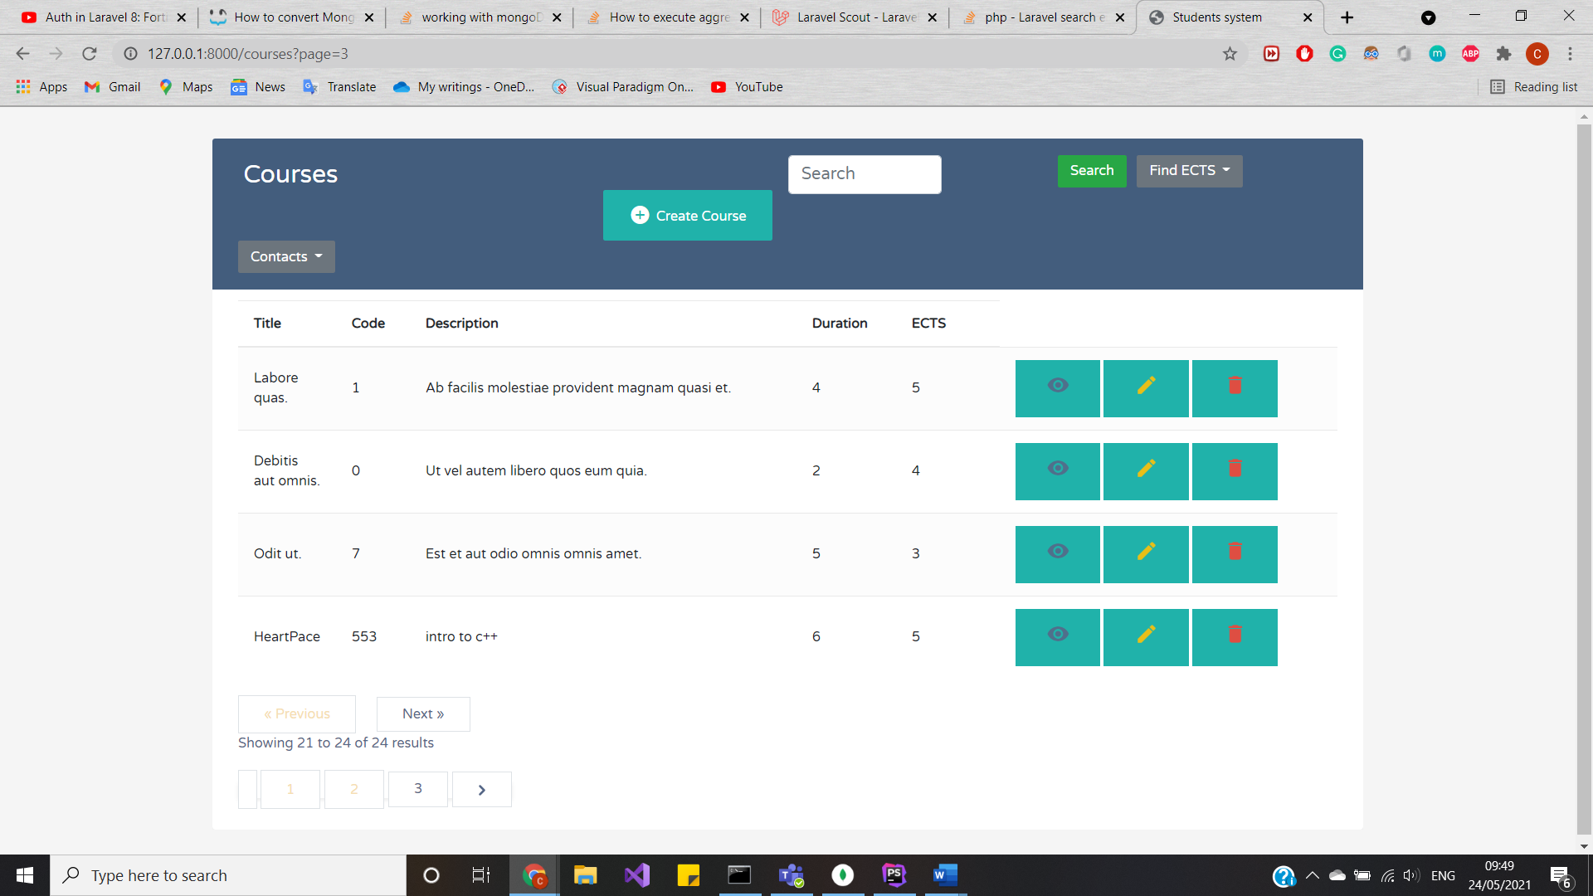

And in compass:

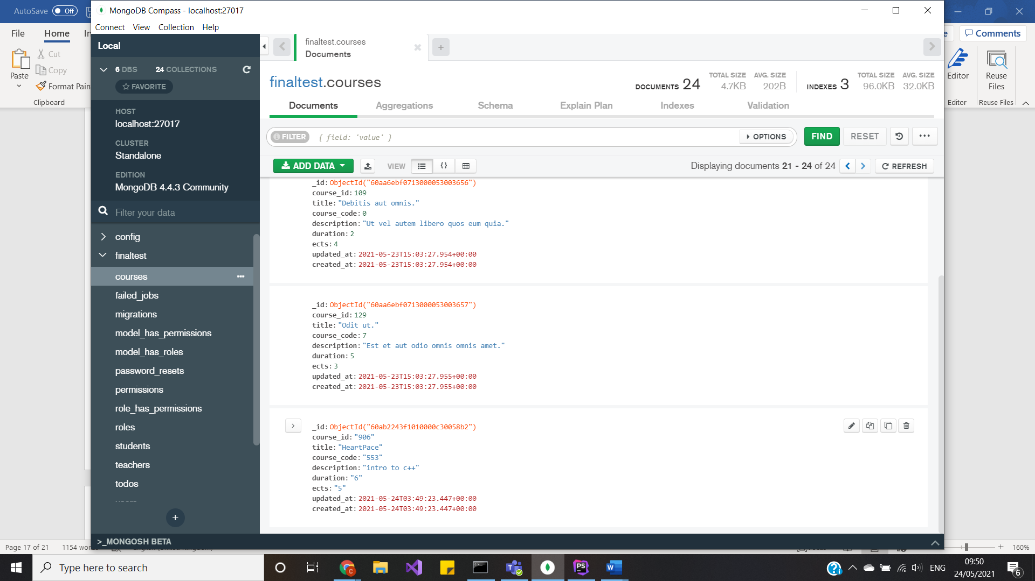

Single read:

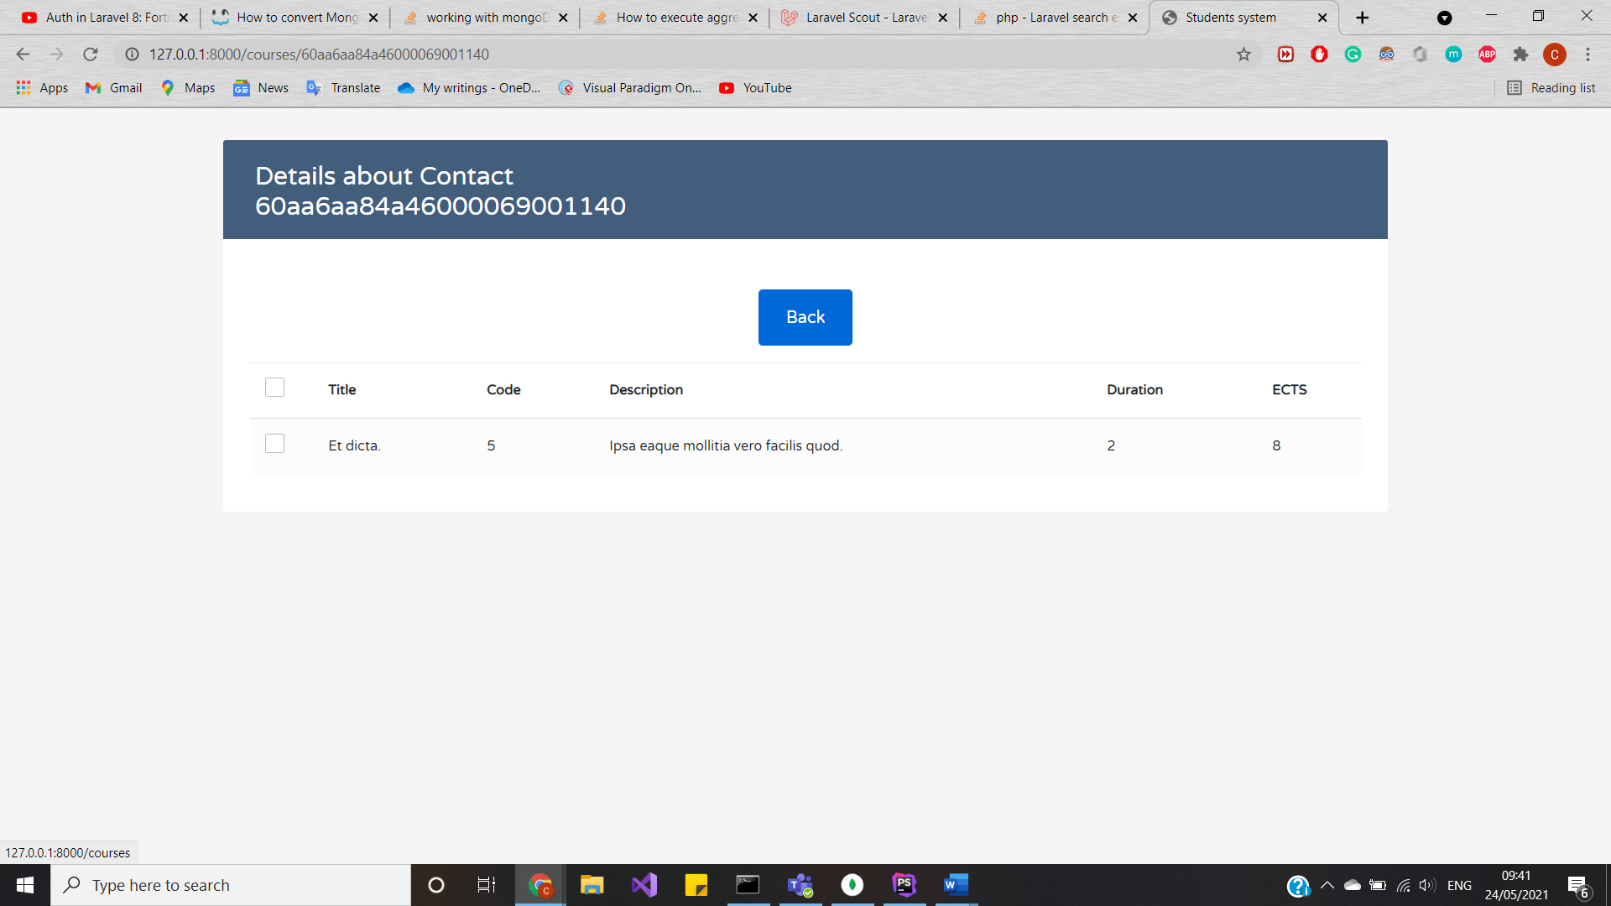

Update:

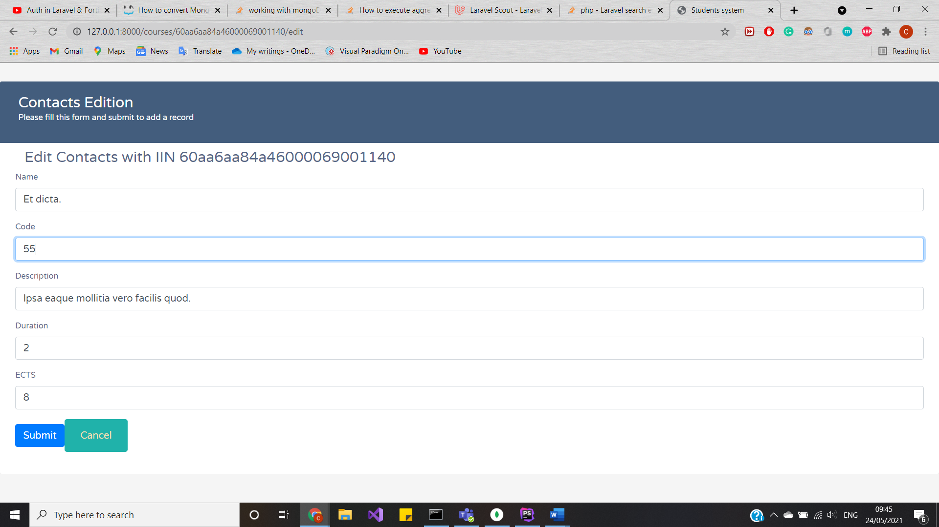

Result:

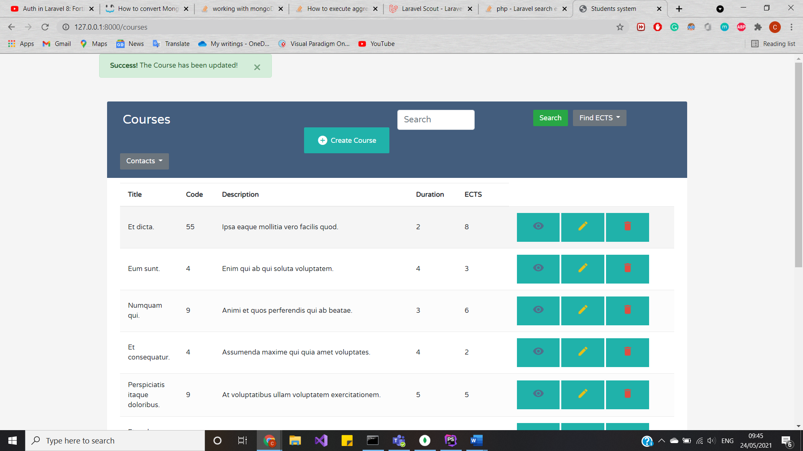

and in driver:

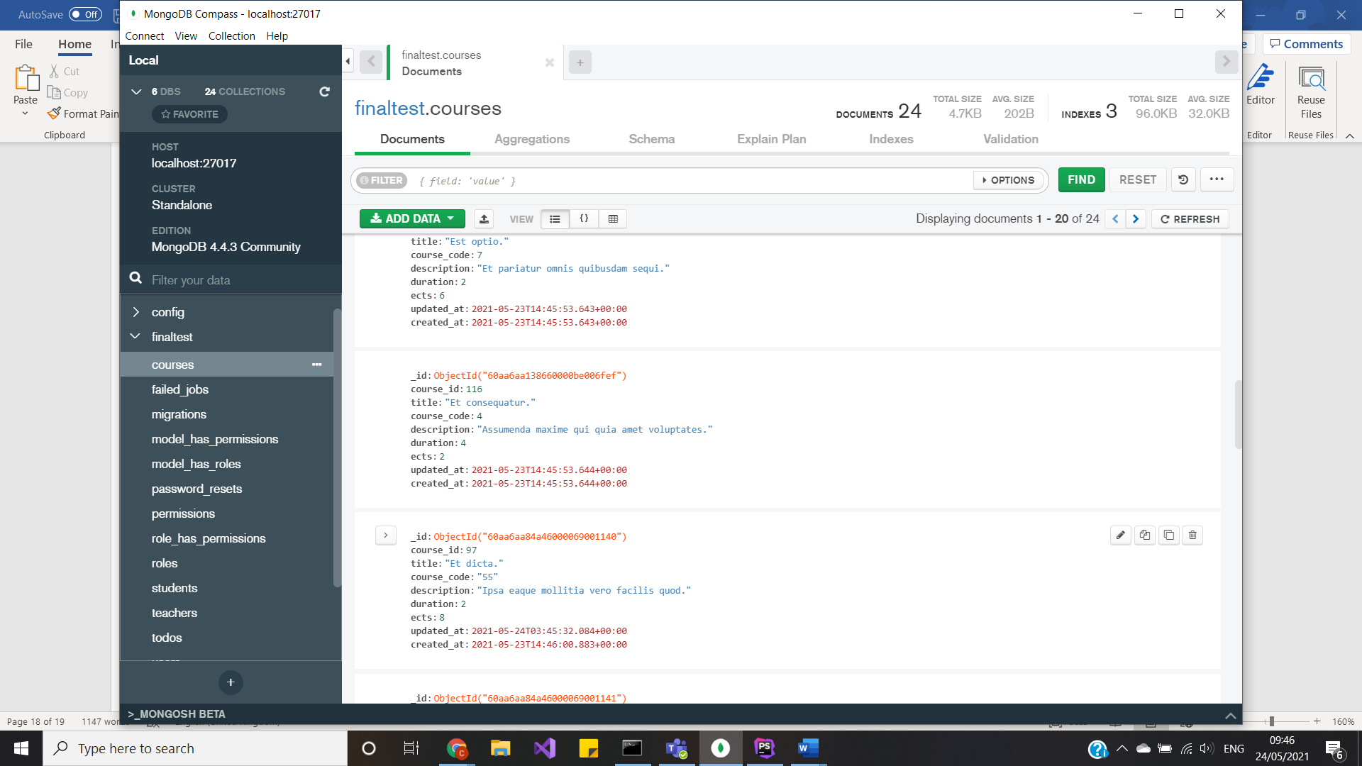

Delete:

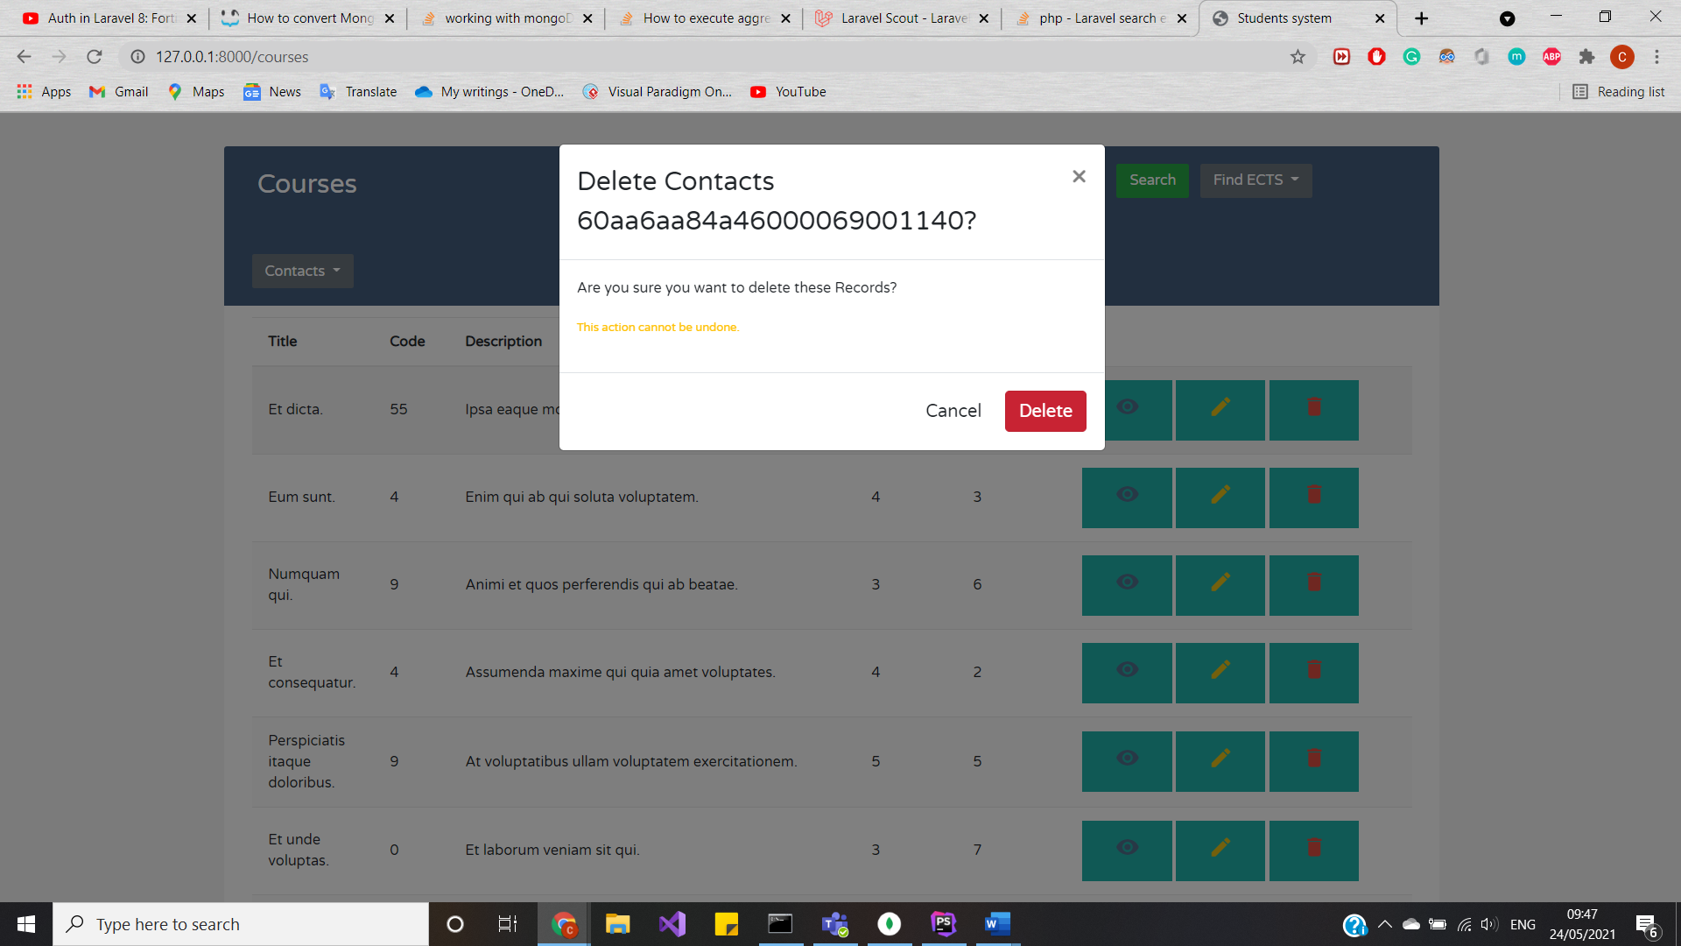

Result:

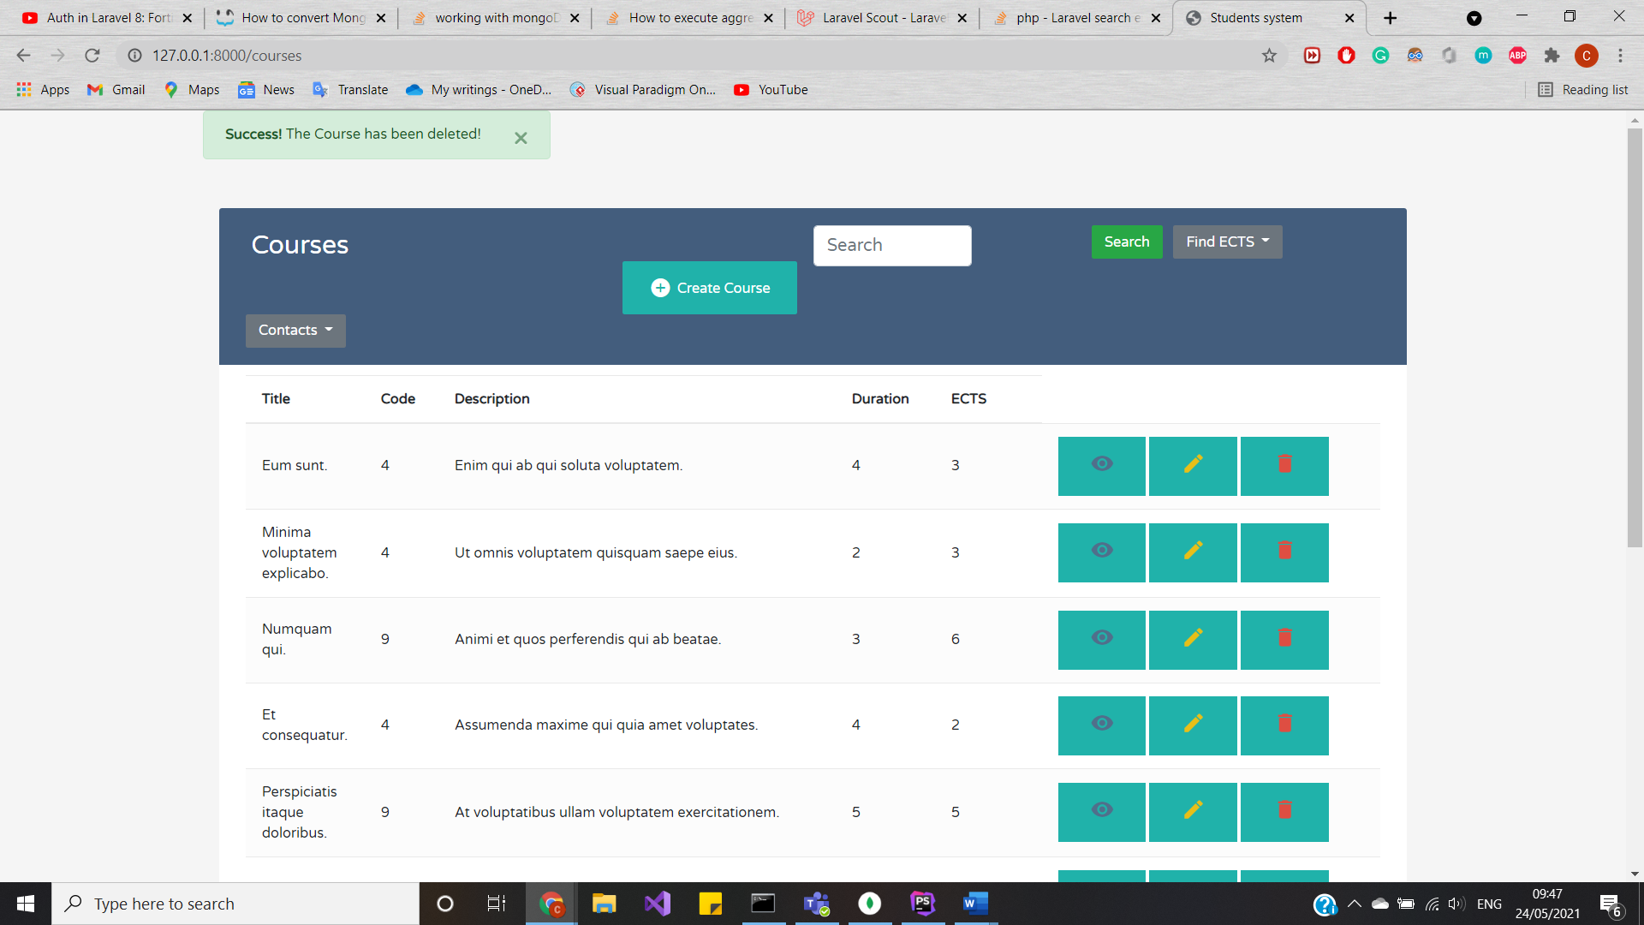 and in driver:

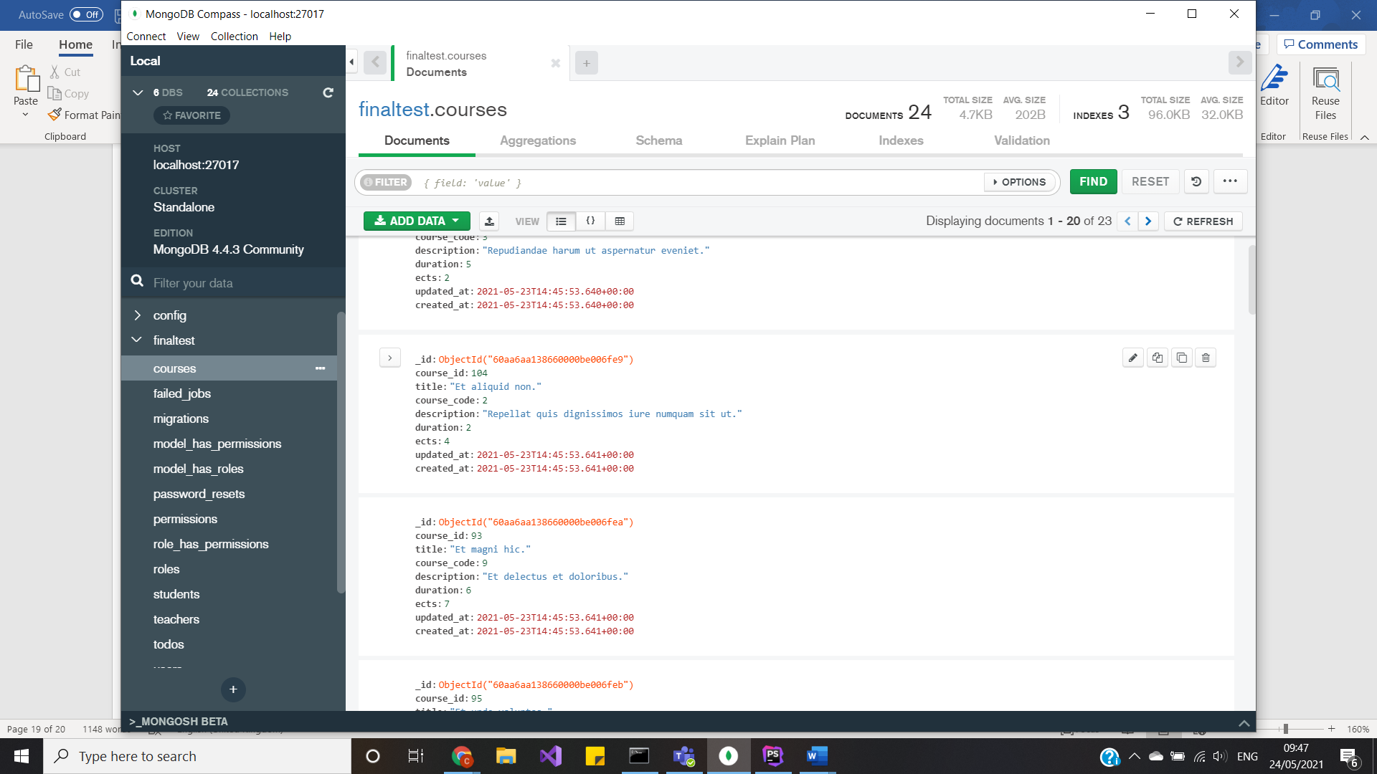

Here is the example of usage the sample project.

Summary

In conclusion, the simple work has been done. Easy and simple way of befriending Laravel 8 framework with Mongo DB, simple queries, yet important fundamentals. I learnt how to connect and convert MongoDB aggregation to Laravel appropriate queries. The main idea behind this project to understand that NoSQL databases are reliable data centers to store data and may be a bit harder to use, yet it is more sufficient and no worse than using SQL structured databases; such database reusable, flexible and once you learn how to convert to Laravel framework, then it is easier to work with. Also, to grasp idea of how to work with MongoDB cloud and driver, not just applying queries to dataset. Moreover, to see how web applications can function on json files. This paper explains the usage and importance of non-relational databases and shows the sample code implementation as well the results of such code.

The link for whole project: <https://github.com/MillaPy/Mongodb-project> .

References

Forums – where I asked for help with errors and exception handling:

* + Stackoverflow
  + Github
  + Doc.Laravel
  + Cloud.mongodb
  + Docs.mongodb
  + Stevencotterill
  + Laracast

Tutorials – where I followed right way of connection to database and MongoDB aggregation in Laravel:

* + flowkl
  + faun.pub
  + codesheef
  + Youtube
  + Opensourceagenda
  + Morioh.com

Papers – about Laravel and MongoDB compatibility, SQL vs NoSQL:

* + medium.com
  + habr.com
  + mongodb.com
  + docs.laravel